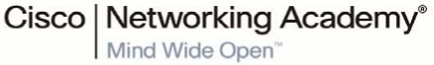

|  |  |
| --- | --- |
| Student Name | Samuel Asuoha |
| Student ID | C00305107 |
| Course ID | CW_KRSIT_H |
| Lab Group |  |

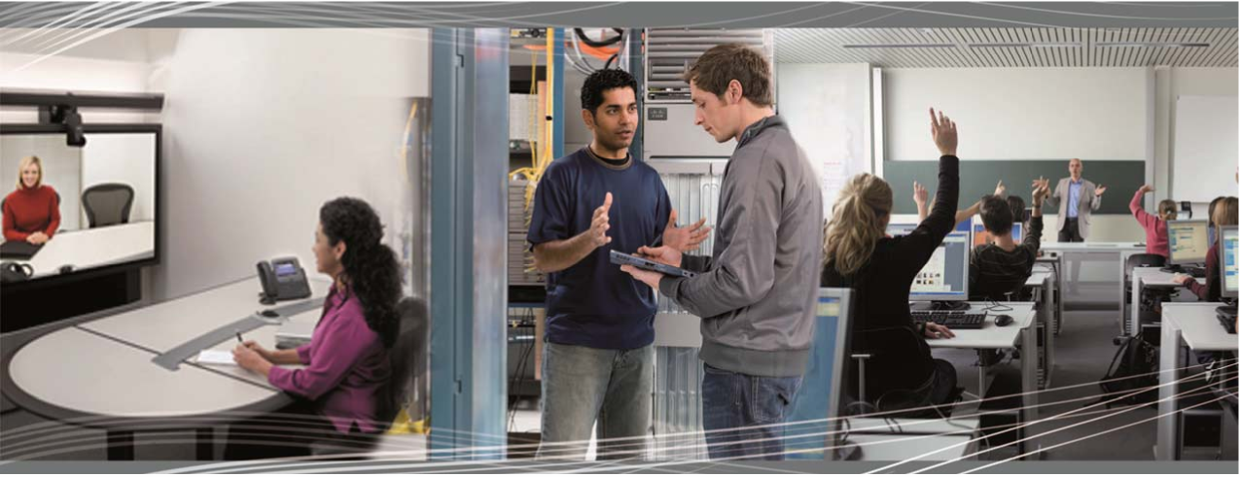

CCNA Routing and Switching:

Introduction to Networks 6.0

CFY Net Student Lab Manual Chapter 01-06



**Table of Contents**

Introduction: 3

Chapter 1: Exploring The Network 4

Lab 1.1 Draw Your Concept of the Internet 4

Lab 1.2 Research Network Converged Services 6

Lab 1.3 Packet Tracer Intro 8

Lab 1.4 Draw Your Concept of the Internet Now 9

Chapter 2: Configure a Network Operating System 10

Lab 2.1 It’s Just an Operating System 10

Lab 2.2 Establish a Console Session 12

Lab 2.3 Build a Simple Network 16

Lab 2.4 Configure a Switch Management Address 24

Chapter 3: Network Protocols & Communication 30

Lab 3.1 Designing a Communications System 30

Lab 3.2 Researching Networking Standards 31

Lab 3.3 Using Wireshark to View Network Traffic 32

Chapter 4: Network Access 40

Lab 4.1 Managing the Medium 40

Lab 4.2 Identifying Network Devices & Cabling 43

Lab 4.3 Build an Ethernet Cable 45

Lab 4.4 Viewing Wired & Wireless NIC Info 50

Lab 4.5 Connecting g Wired & Wireless Nets (PT) 57

Lab 4.6 Linked In (Cabling Technology) 62

Chapter 5: Ethernet 64

Lab 5.1 Use Wireshark to Examine Ethernet Frames 64

Lab 5.2 View Network Device MAC Addresses 70

Lab 5.3 Observe ARP with Windows CLI & IOS CLI 75

Lab 5.4 Examine Switch MAC Address Table 82

Chapter 6: Network Layer 87

Lab 6.1 Exploring Router Physical Characteristics 87

Lab 6.2 View Host Routing Tables 91

Lab 6.3 Create Network Topology Network Using Routing Table 93

Lab 6.4 Build a Router & Switch Network 95

Appendices: 99

Appendix A: Network Device Symbols 99

Appendix B: Useful IOS Commands (CFY Net CA1 Lab Exam) 100

Appendix C: Useful IOS Commands (CFY Net CA2 Lab Exam) 101

Appendix D: Physical Device Cabling 102

Appendix E: Switch & Router Password Reset 105

Appendix F: Initializing & Reloading a Switch 106

## Introduction:

1. **Before You Begin:**

* Write your name, ID, lab group, & course info on the cover of your lab book
* Tin this lab manual there are six chapters, each containing several lab exercises
* There are several appendices to help you with the lab exercises
* Before you begin, read the notes below
* Each week you will have a two-hour lab, a one-hour tutorial, and a one-hour lecture

1. **Cisco CCNA:**

* These lab exercises are based on:

**Cisco CCNA Routing and Switching: Introduction to Networks 6.0, chapters** 1-6

* (CCNA: Cisco Certified Network Associate)
* You will be given a Cisco Netacad login so you can study the course material online
* <https://www.netacad.com/>

1. **Lab Procedure:**

* Lab exercises usually have three sections:
* **Objectives**: Purpose of lab
* **Lab Tasks**: List of lab steps
* **Lab Work**: Step-by-step lab guidelines. This is the section you must complete.
* Answer lab questions in the spaces provided
* Some labs can be completed using Cisco physical equipment (routers, switches, etc.) or using Cisco Packet Tracer (Networking simulation tool) or both
* Others labs use the college network
* Ensure you erase your router or switch configurations when labs are completed
* Do **NOT** set passwords on physical devices
* Before attempting physical labs, sketch your configuration

1. **Marking:**

* Lab exercises count for 20% of overall marks
* Lab exams count for 40% of overall marks
* Your lab instructor will check your lab book from time to time
* Most labs require checking/sign-off from lab instructor

# Chapter 1: Exploring The Network

## Lab 1.1 Draw Your Concept of the Internet

Objective:

* Demonstrate that networks are made of many different components

Lab Tasks:

* Draw & label a map of the Internet as you see it

1. 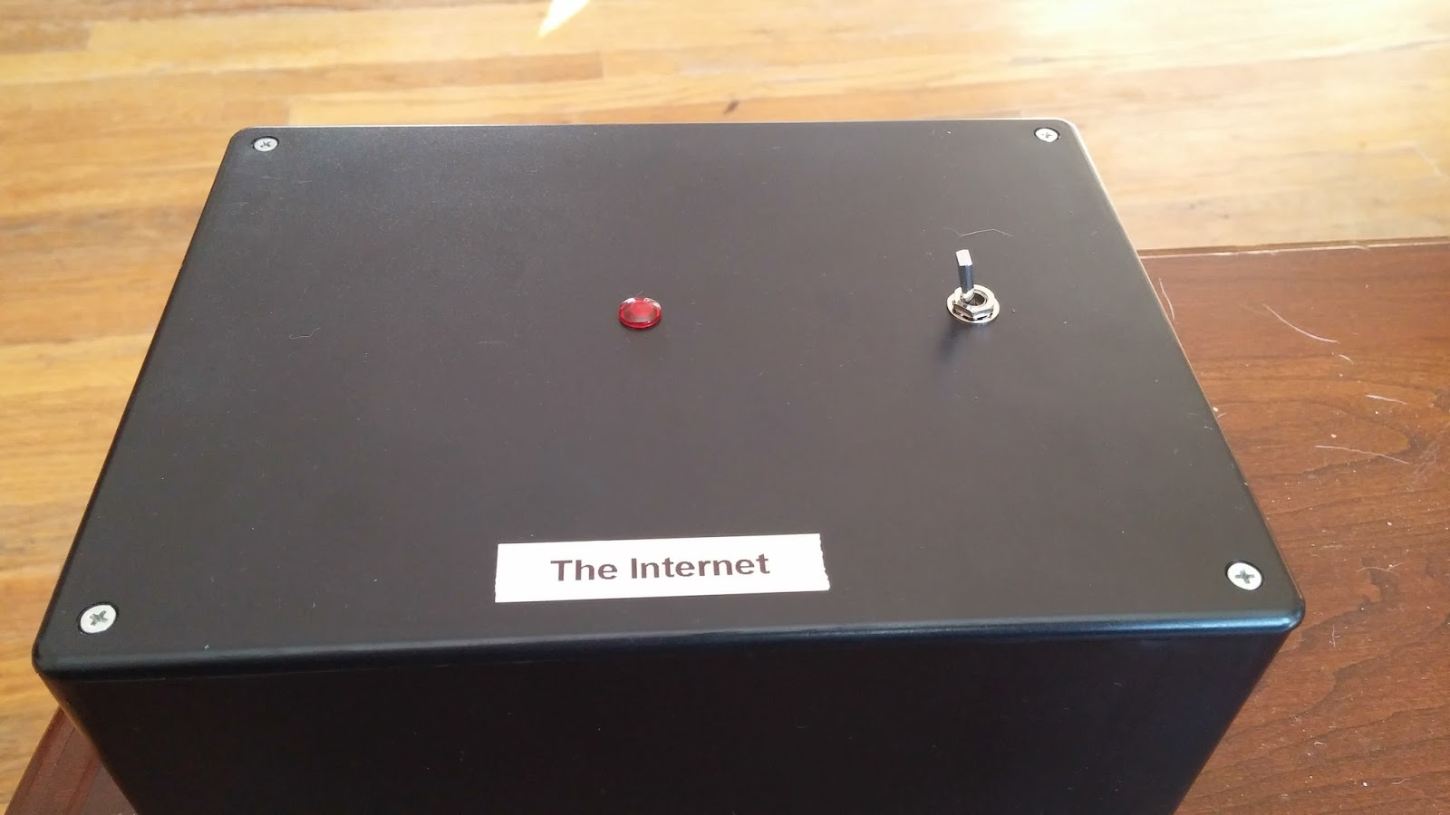**Draw the Internet**
2. **Review your classmates drawings**
3. **Reflection**

Lab Work:

1. **Draw the Internet**

* Below, draw what you see as the Internet
* Include your home or college location and its respective cabling, equipment, devices, etc.
* Some items you may want to include:
* Devices, media (cabling), addresses or names, sources/destinations, ISPs
* For an example to get you started, please visit: <http://www.kk.org/internet-mapping>.

1. **Review your classmates drawings**

* Swap your drawings with others at your bench
* Next, answer the questions below

1. **Reflection**

* Were there computer devices that you could have included on your diagram? _________
* If so, which ones and why?
* How were some of the model designs the same or different?
* What modifications would you make to your drawing after reviewing the other drawings
* In what way could icons on a network drawing provide a streamlined thought process and facilitate your learning?
* Instructor Sign-off: ___________________________________________________

## mage result for voice video and dataLab 1.2 Research Network Converged Services

**Lab 1.2 Research Network Converged Services**

Objective:

* Convergence in the context of networking is a term used to describe the process of combining voice, video, and data communications over a common network infrastructure
* In this lab, you will research the converged services available to you

Lab Tasks:

1. **Describe convergence**
2. **Research various ISPs that offer converged services**
3. **Choose Best ISP converged Service Offering**
4. **Research local companies using convergence technologies**
5. **List advantages/disadvantages of converged services**
6. **What is Net Neutrality?**

Lab Work:

1. **Describe convergence**

* Describe convergence in your own words

Network convergence refers to the integration of various communication networks—such as data, voice, and video—into a single infrastructure. This integration facilitates smooth communication and collaboration among users, regardless of the data type or media being used.

Key Aspects of Network Convergence:

Integration of Networks: Combines different networks, including wired, wireless, and IoT, into a cohesive infrastructure.

Unified Management: Allows for centralized management, simplifying operations and boosting efficiency.

Cost Savings: Consolidates resources and eliminates redundancy, leading to significant financial benefits.

Improved Flexibility: Easily adapts to changing business requirements and new technologies.

Enhanced User Experience: Provides users with a seamless communication experience, offering access to various services through a single network.

Examples of Network Convergence:

Unified Communications: Merges voice, video, and data into one platform, enabling features like video conferencing, instant messaging, and file sharing.

Internet of Things (IoT): Connects devices and sensors to a network for data collection, analysis, and automation.

Cloud Computing: Offers computing resources over a network, allowing access to applications and data from anywhere.

Benefits of Network Convergence:

Reduced Complexity: Simplifies management by minimizing the need for multiple systems.

Improved Efficiency: Streamlines operations and optimizes resource use.

Cost Savings - lowers operational expenses through infrastructure consolidation.

Increased Flexibility: Easily accommodates evolving business needs and emerging technologies.

Enhanced User Experience: Delivers a more integrated communication experience.

Challenges of Network Convergence:

Security: Protecting sensitive data and guarding against cyber threats.

Interoperability: Ensuring compatibility across diverse systems and technologies.

Complexity: Managing a sophisticated and integrated network infrastructure.

Cost: Upfront investments in new equipment and staff training.

Network convergence presents substantial advantages for organizations, enabling enhanced efficiency, reduced costs, and improved competitiveness in today’s digital environment.

* Provide examples of its use in the home

 Having Wi-fi, wired and IoT devices under a centralised hub or management like Google Hive to ensure all the devices are operating correctly and efficiently without signing into your routers, monitoring individual SNMP traffic from devices or monitoring for vulnerabilities from individually assigned devices.   
For example, having your bulbs, heating and streaming devices being centralised with updates being pushed down from Google Hive.

1. **Research various ISPs that offer converged services**

* List 3 ISPs in your area & complete the form below

|  |  |  |  |
| --- | --- | --- | --- |
| **Internet Service Provider** | **Product Name of Converged Service** | **Cost per Month** | **Download Speed** |
| Vodafone | Vodafone 2 Gigabit Full Fibre Broadband | €60 | 2gb |
| Virgin Media | Virgin Media 2Gb Broadband - 24 Month Discount | €55 | 2gb |
| Eir | eir Gigabit Broadband, Talk | €49.99 | 1gb |

1. **Choose Best ISP converged Service Offering**

* Select your top choice from the list you provided
* Give reasons why you chose that particular one

|  |  |
| --- | --- |
| **Best ISP for Convergence** | **Reasons Why** |
| Virgin Media | Cheapest for the same service and better coverage |

1. **Research local companies using convergence technologies**

* List 2 companies or organisations in your area that use convergence technologies

|  |  |  |
| --- | --- | --- |
| **Name of Company** | **Industry** | **Convergence Technologies** |
| Scope Technology Group | Technology and building services | Integrated Security Systems |
| Accenture Ireland | Consulting, digital transformation, technology, and outsourcing services | Cloud Computing |

1. **List advantages/disadvantages of converged services**

|  |  |
| --- | --- |
| **Advantages** | **Disadvantages** |
| Simplified management | Complex troubleshooting |
| Improved customer experience | Network congestion |
| Cost efficient | Increased Security Risks |

1. **What is Net Neutrality?**

* Extra topic if time permits
* Discuss this term in relation to:
* Common Carriers, ISPs, Internet Content Providers, FCC

* **Common Carriers:** These are companies that provide public utility services like telecommunications. Net neutrality would treat ISPs as common carriers, preventing them from prioritizing specific types of traffic.
* **ISPs:** ISPs play a crucial role in the debate, as they would prefer to charge more for faster access to certain websites or services.
* **Internet Content Providers:** Content providers like Netflix or Google could be at a disadvantage if ISPs prioritize access to their competitors’ content.
* **FCC:** The Federal Communications Commission (FCC) in the U.S. regulates internet services and has been central to the ongoing debate about whether or not to enforce net neutrality.
* Instructor Sign-off: ___________________________ Date: _______________

## Lab 1.3 Packet Tracer Intro

Objective:

* Become familiar with Cisco Packet Tracer software (version 7)
* In this lab, you will go through basic examples & tutorials

Lab Tasks:

* Cisco Packet Tracer is a network simulator used to create & troubleshoot networks
* Available (free) for Windows, Linux, IOS & Android (not Mac!)

1. **Run YouTube intro video**
2. **Start Using PT**
3. **Try Netacad Exercises**

Lab Work:

1. **Run YouTube intro video**

* This video uses an older version of PT, but is an excellent introduction
* Watch the video & then move on to step 2. You can go back to the video anytime

<http://www.youtube.com/watch?v=3wz8qI_nBK4> (7 mins.)

1. **Start Using PT**

* Open PT & re-create the network in the video

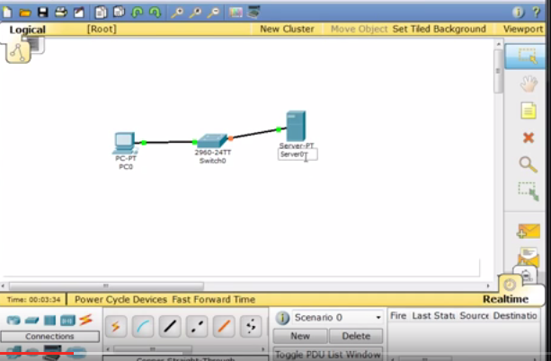

1. **Try Netacad Exercises**

* Have a look at lab activities 1.2.4.4 & 1.2.4.5 in your Netacad course
* Download PT for use on your home devices

## Lab 1.4 Draw Your Concept of the Internet Now

Objective:

* Identify the common components of a network
* Use device icons to visualise network connectivity

Lab Tasks:

1. **Draw a map of the Internet as you see it now**
2. **Netacad Activity: Network Representation & Functions**

Lab Work:

1. **Draw a map of the Internet as you see it now**

* Refer back to first lab (1.1 above)
* Below, draw what you see as the Internet
* Include in your drawing: Devices/Equipment, Media/Cabling, LANs, WANs, Cloud, ISP
* Use standard icons where possible (refer to Appendix A)
* Review your classmates drawings

1. **Netacad Activity: Network Representation & Functions**

* Complete Netacad online activity 1.2.7.1 (network icons, etc.)
* <https://www.netacad.com/>
* Instructor Sign-off: ___________________________ Date: _______________

# Chapter 2: Configure a Network Operating System

## Lab 2.1 It’s Just an Operating System

Objective:

* Use car voice commands analogy to help understand the command structure of Cisco IOS
* Work in groups

Lab Tasks:

* Describe structure of voice command language

1. **Outline command hierarchy**
2. **Try practice run**
3. **Discuss how these commands could be used in an IOS**

Lab Work:

1. **Outline command hierarchy**

* Your company has developed a voice-controlled car
* Design a set of commands used by this voice-activated control system
* The functions of the car that can be controlled by voice commands are:

|  |  |  |  |  |  |
| --- | --- | --- | --- | --- | --- |
| Lights | Wipers | Radio | Telephone | A/C | Ignition |

* Sketch your command hierarchy for each function below

Lights:

Lights On/Off, Set Brightness, Headlights On/Off, High Beams On/Off, Fog Lights On/Off

Wipers:

Wipers On/Off, Set Speed, Rear Wipers On/Off, Spray Washer Fluid

Radio:

Radio On/Off, Set Volume, Change Station, Next/Previous Station, Play Bluetooth

Telephone:

Call [Contact], End/Answer Call, Mute/Unmute Microphone

A/C:

A/C On/Off, Set Temperature, Increase/Decrease Temperature, Set Fan Speed

Ignition:

Start Engine, Stop Engine, Activate Remote Start

1. **Try practice run**

* Test your system by (e.g. turning on rear wipers on and then off)

**>** **Commands tested: Rear Wipers On, Rear Wipers Off**

1. **Discuss how these commands could be used in an IOS**

* How does this relate to Cisco IOS?
* Look at the Cisco IOS command for (e.g.) setting an IP address
* What have the two systems got in common?
* List potential disruptive commands in each system

a) Both the car’s voice command system and Cisco IOS commands use a hierarchical structure. In the car system, you issue commands in a structured manner (e.g., “Wipers -> Rear Wipers On”), just like in Cisco IOS (e.g., “interface -> IP address 192.168.1.1 255.255.255.0”).

b) In Cisco IOS, the command for setting an IP address follows this structure:

Router> enable

Router# configure terminal

Router(config)# interface FastEthernet0/1

Router(config-if)# ip address 192.168.1.1 255.255.255.0

c) >Both systems require precise commands in a structured hierarchy.

>Both are designed to execute specific functions and require a specific syntax to avoid misinterpretation.

>Both systems have default settings and context-specific commands

d) >Car System:

**Turn Off Engine** while driving.

**Disable Brakes**.

**Turn Off All Lights** at night.

>Cisco IOS:

**reload** without saving configuration (reboots the device without saving).

**erase** startup-config (removes configuration settings).

**shutdown** (turns off an interface, potentially disrupting network connectivity).

* Instructor Sign-off: ___________________________ Date: _______________

## Lab 2.2 Establish a Console Session

Objectives:

* Access a switch using terminal emulation software
* Complete lab in PT & on physical devices
* Before attempting physical labs, sketch your configuration

Lab Tasks:

* Connect to switch through serial console port or USB port (newer devices)

**Part 1: Access a Cisco Switch through Serial Console Port**

1. **Configure Terminal to establish a console session with the switch**
2. **Connect a Cisco switch and computer using a rollover console cable**
3. **Test connection is working**

**Part 2: Display & Configure Basic Device Settings**

1. **Display switch IOS image version**
2. **Configure the clock**

**Part 3: Access a Cisco Router using Mini-USB Console Cable**

1. **Configure Terminal to establish a console session with the switch??**
2. **Connect a Cisco switch and computer using USB Cable**

Lab Work:

**Part 1: Access a Cisco Switch through Serial Console Port**

* Connect to switch through serial console port

1. **Configure Terminal to establish a console session with the switch**

* On your PC, open the Terminal program
* Click on Serial/COM1
* Click OK
* Should see empty screen

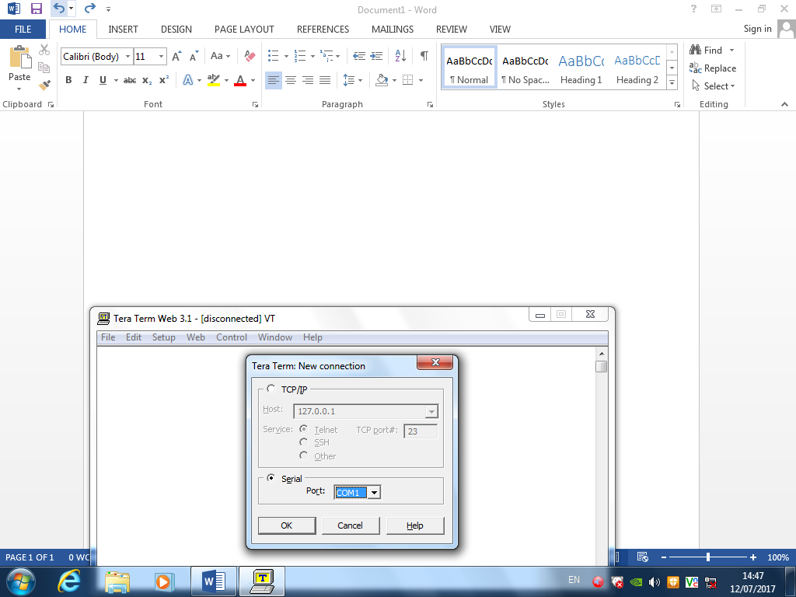

1. **Connect a Cisco switch and computer using a rollover console**

* Identify your bench. E.g. **2C**
* Find your socket number for console connection: Blue console cable connected from your PC to socket on desk. E.g. **2C14**
* Connect blue Cat5 cable from Patch Panel socket **2C14** to console port on any available router or switch. Power on router/switch

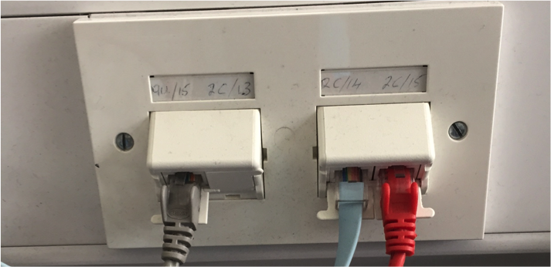

Cables left to right:

Grey, Blue, Red

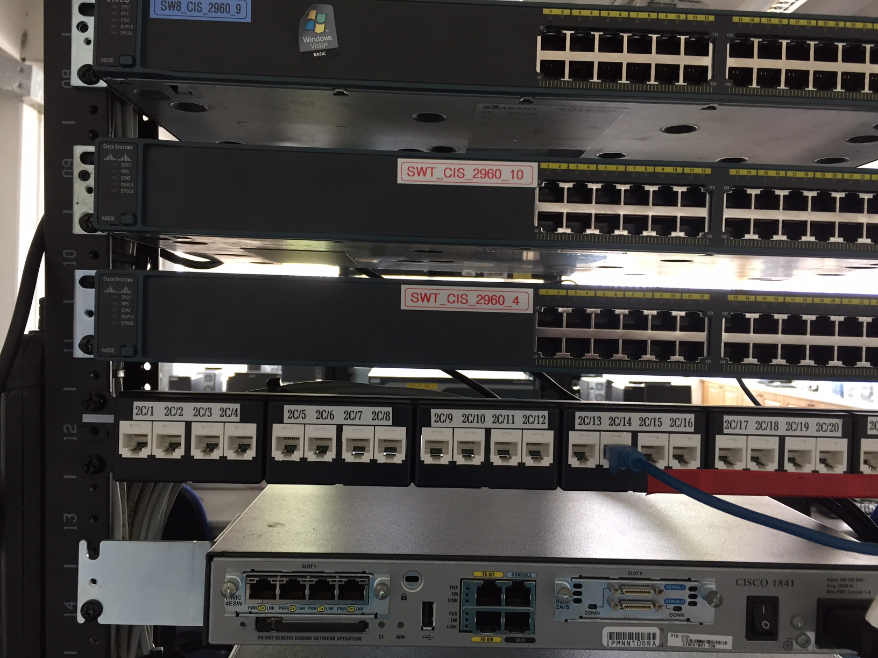

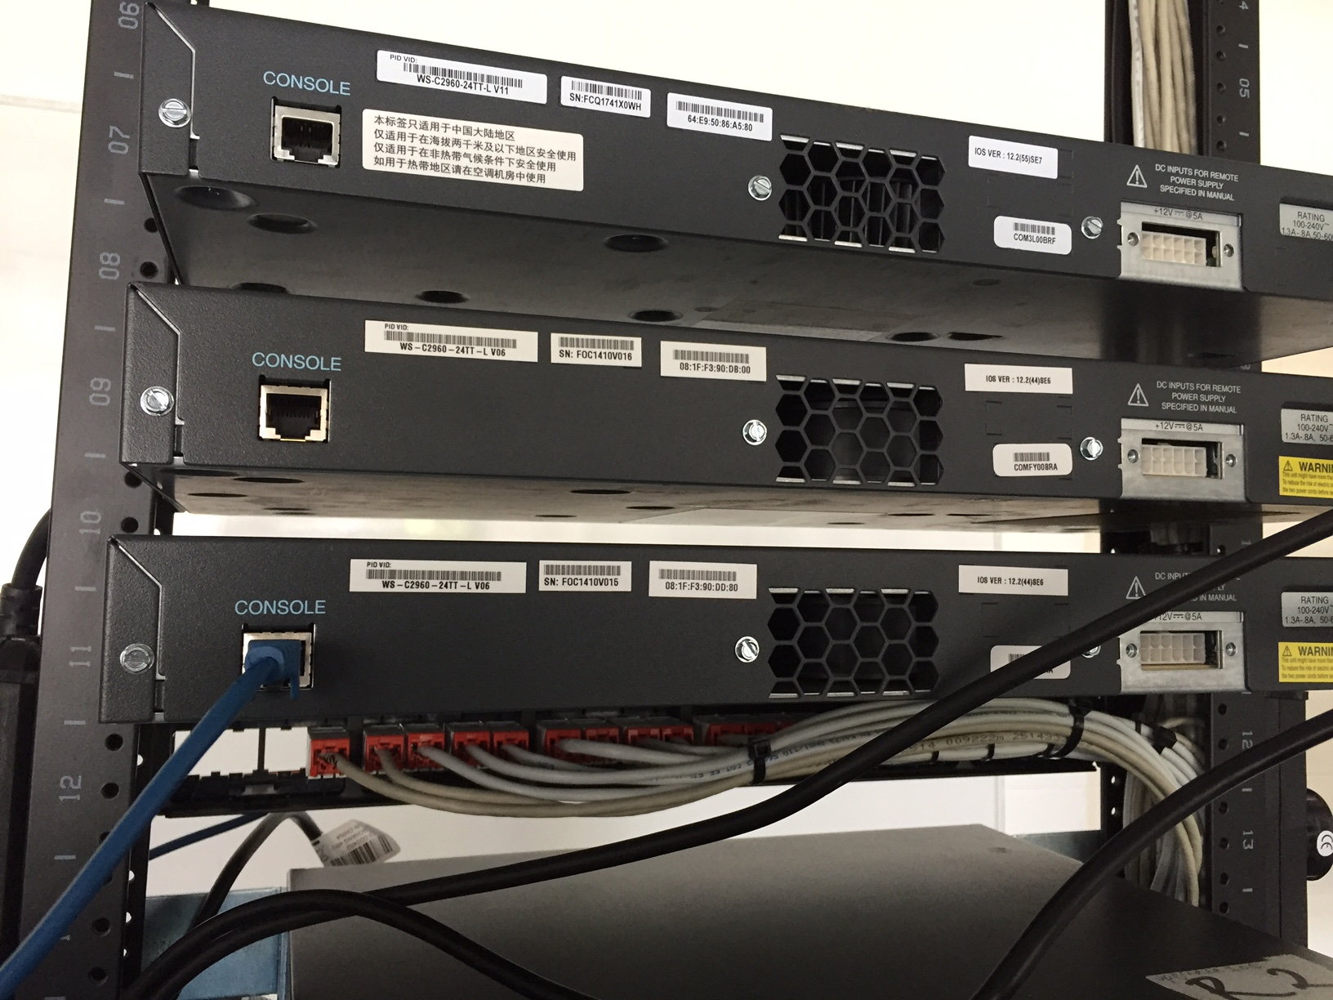

1. **Test connection is working**

* Check output on Terminal window (Step 1)
* Should see switch booting up!
* On Terminal, press CTRL-C when startup completes
* This brings you to CLI (Command Line Interface)

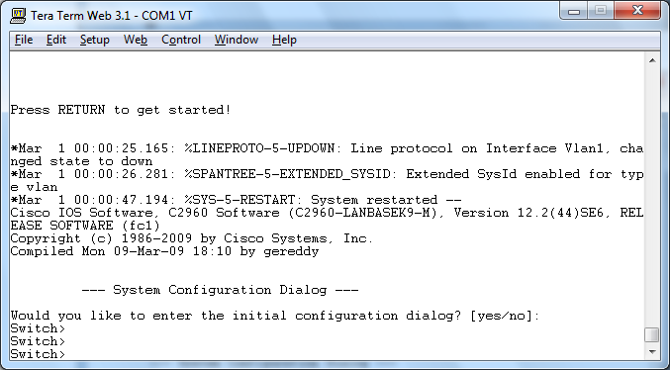

**Part 2: Display & Configure Basic Device Settings**

* Intro to user & privileged modes
* Determine IOS version & configure clock

1. **Display switch IOS image version**

* Switch> **show version**
* Write down the IOS version of your switch below
* Should get output similar to:

Switch> **show version**

Cisco IOS Software, C2960 Software (C2960-LANBASEK9-M), Version 15.0(2)SE, RELEASE SOFTWARE (fc1)

Technical Support: http://www.cisco.com/techsupport

Copyright (c) 1986-2012 by Cisco Systems, Inc.

Compiled Sat 28-Jul-12 00:29 by prod_rel_team

ROM: Bootstrap program is C2960 boot loader

BOOTLDR: C2960 Boot Loader (C2960-HBOOT-M) Version 12.2(53r)SEY3, RELEASE SOFTWARE (fc1)

Switch uptime is 2 minutes

System returned to ROM by power-on

System image file is "flash://c2960-lanbasek9-mz.150-2.SE.bin"

**<output omitted>**

|  |  |
| --- | --- |
| IOS Version |  |

1. **Configure the clock**

* Display current settings:

Switch> **show clock**

* You can change the clock setting in the privileged EXEC mode
* Follow the steps below to set clock to current time & date
* The question mark (?) provides help and allows you to determine the expected input

Switch> **enable**

Switch# **clock set ?**

hh:mm:ss Current Time

Switch# **clock set 15:08:00 ?**

<1-31> Day of the month

MONTH Month of the year

Switch# **clock set 15:08:00 Oct 26 ?**

<1993-2035> Year

Switch# **clock set 15:08:00 Oct 26 2012**

Switch#

*Oct 26 15:08:00.000: %SYS-6-CLOCKUPDATE: System clock has been updated from 00:31:43 UTC Mon Mar 1 1993 to …., configured from console by console.

* Enter the **show clock** command to verify that the clock setting has updated.

Switch# **show clock**

15:08:07.205 UTC Fri Oct 26 2012

* Instructor Sign-off: ___________________________ Date: _______________

## Lab 2.3 Build a Simple Network

Topology:

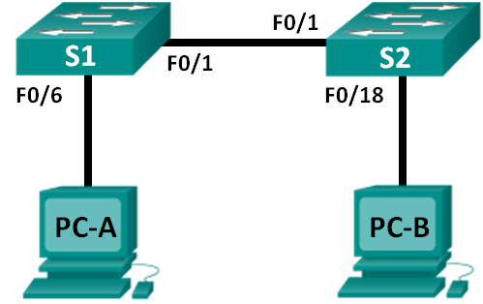

1. Addressing Table:

|  |  |  |  |
| --- | --- | --- | --- |
| Device | Interface | IP Address | Subnet Mask |
| PC-A | NIC | 192.168.1.10 | 255.255.255.0 |
| PC-B | NIC | 192.168.1.11 | 255.255.255.0 |

Objectives:

* Build a simple network with two hosts & two switches
* Complete in PT & on physical devices.
* Before attempting physical labs, sketch your configuration
* Do in Packet Tracer first
* Work in groups for physical lab!
* Sign off by lab instructor for each student for PT & physical lab completion:

|  |  |  |
| --- | --- | --- |
| **Lab** | **Lab** | **Instructor Signature** |
| Lab 2.3 | Packet Tracer Lab |  |
| Lab 2.3 | Physical Lab |  |

* **Note: if you are using 2950 switches, or connecting 2950 to 2960, you will need a crossover cable**

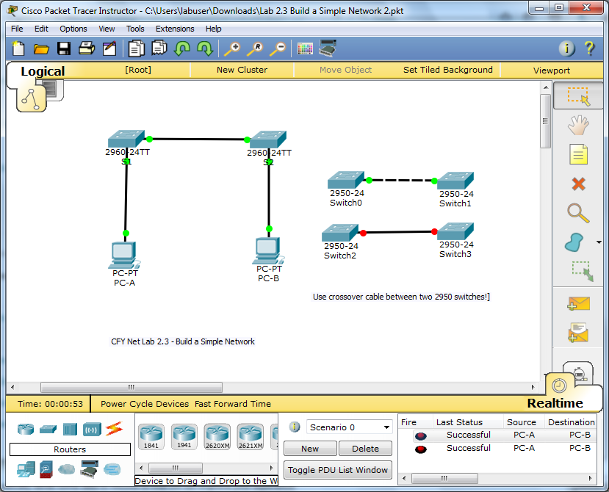

Lab Tasks:

**Part 1: Set up the Network Topology**

1. **Power on the Devices**
2. **Connect the two switches**
3. **Connect PCs to switches**
4. **Inspect network connections**

**Part 2: Configure PC Hosts**

1. **Configure static IP address info on each PC**
2. **Verify PC settings & connectivity**

**Part 3: Configure & Verify Basic Switch Settings**

1. **Console into the switch**
2. **Enter privileged EXEC Mode**
3. **Enter configuration Mode**
4. **Give switch a name**
5. **Prevent unwanted DNS lookups**
6. **Enter local passwords**
7. **Enter a login MOTD banner**
8. **Save the configuration**
9. **Display the current configuration**
10. **Display IOS version & other useful switch info**
11. **Display status of connected interfaces on the switch**
12. **Repeat Steps 1-12 to configure switch S2**
13. **Record device interface status**
14. **Erase device configurations**

(Adapt the wiring diagram created in tutorial for physical lab)

Lab Work:

**Part 1: Set up the Network Topology**

* Cable a physical lab topology

1. **Power on the Devices**

* Power on all devices. Note: switches do not have a power switch.

1. **Connect the two switches**

* Connect one end of an Ethernet cable to F0/1 on S1 & the other end of the cable to F0/1 on S2
* You should see the lights for F0/1 on both switches turn amber and then green. This indicates that the switches have been connected correctly.

1. **Connect PCs to switches**

* Connect one end of the second Ethernet cable to the NIC port on PC-A
* Connect the other end of the cable to F0/6 on S1
* After connecting the PC to the switch, you should see the light for F0/6 turn amber and then green, indicating that PC-A has been connected correctly.
* Connect one end of the last Ethernet cable to the NIC port on PC-B. Connect the other end of the cable to F0/18 on S2
* After connecting the PC to the switch, you should see the light for F0/18 turn amber and then green, indicating that the PC-B has been connected correctly.

1. **Inspect network connections**

* Carefully verify the connections to minimize time required to troubleshoot connectivity issues later

**Part 2: Configure PC Hosts**

* Enter IP address info & verify connectivity using **ping**
* Note: configuration will be slightly different in PT

1. **Configure static IP address info on each PC**

* Do this for PC-A & PC-B
* Click on Network… icon on bottom RHS of screen
* 🡪 Local Area Connection (CCNA) 🡪 Properties 🡪 TCP/IPv4
* Enter the IP address from the addressing table 🡪 OK 🡪 OK

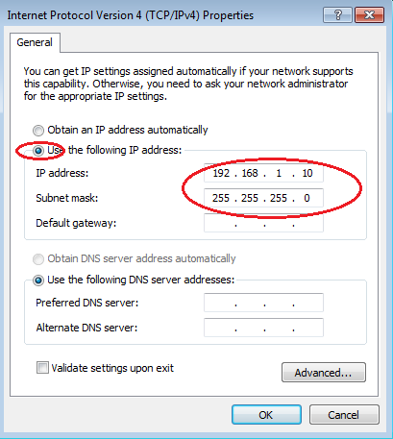

1. **Verify PC settings & connectivity**

* Open a command window on each PC
* Ping PC-A to PC-B & PC-B to PC-A
* Should all be successful!

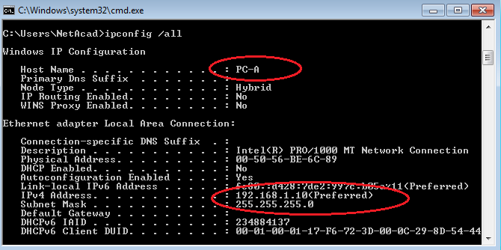

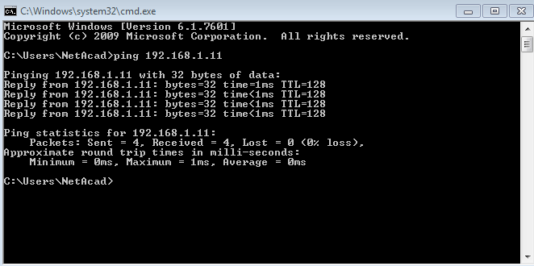

|  |  |  |  |
| --- | --- | --- | --- |
| **From** | **To** | **Result (PT)** | **Result (Physical)** |
| PC-A | PC-B |  |  |
| PC-B | PC-A |  |  |

**Part 3: Configure & Verify Basic Switch Settings**

* Configure each switch with hostname, passwords & login banner
* Note: configuration will be slightly different in PT

1. **Console into the switch**

* Use Terminal on PC-A to establish a connection to the switch
* (Refer to the previous lab)

1. **Enter privileged EXEC Mode**

* You can access all switch commands in privileged EXEC mode
* The privileged EXEC command set includes those commands in EXEC mode, plus the **configure** command through which access to the remaining command modes are gained
* Enter privileged EXEC mode by entering the **enable** command

Switch> **enable**

Switch#

* The prompt changed from **Switch>** to **Switch#** which indicates privileged EXEC mode.

1. **Enter configuration Mode**

* Use the **configuration terminal** command to enter configuration mode.

Switch# **configure terminal**

Enter configuration commands, one per line. End with CNTL/Z.

Switch(config)#

* The prompt changed to reflect global configuration mode.

1. **Give switch a name**

* Use the **hostname** command to change the switch name to **S1**.

Switch(config)# **hostname S1**

S1(config)#

1. **Prevent unwanted DNS lookups**

* To prevent the switch from attempting to translate incorrectly entered commands as though they were hostnames, disable the Domain Name System (DNS) lookup.

S1(config)# **no ip domain-lookup**

S1(config)#

1. **Enter local passwords**

* To prevent unauthorized access to the switch, passwords must be configured.

S1(config)# **enable secret class**

S1(config)# **line con 0**

S1(config-line)# **password cisco**

S1(config-line)# **login**

S1(config-line)# **exit**

S1(config)#

1. **Enter a login MOTD banner**

* A login banner, known as the message of the day (MOTD) banner, should be configured to warn anyone accessing the switch that unauthorized access will not be tolerated.
* The **banner motd** command requires the use of delimiters to identify the content of the banner message. The delimiting character can be any character as long as it does not occur in the message. For this reason, symbols, such as the **#**, are often used.

S1(config)# **banner motd #**

Enter TEXT message. End with the character '#'.

**Unauthorized access is strictly prohibited and prosecuted to the full extent of the law. #**

S1(config)# **exit**

S1#

1. **Save the configuration**

* Use the **copy** command to save the running configuration to the startup file on non-volatile random access memory (NVRAM).

S1# **copy running-config startup-config**

Destination filename [startup-config]? **[Enter]**

Building configuration...

[OK]

S1#

1. **Display the current configuration**

* The **show running-config** command displays the running configuration, one page at a time. Use spacebar to advance paging. The commands configured above are highlighted

S1# **show running-config**

Building configuration...

Current configuration : 1409 bytes

!

! Last configuration change at 03:49:17 UTC Mon Mar 1 1993

version 15.0

no service password-encryption

!

hostname S1

!

enable secret 4 06YFDUHH61wAE/kLkDq9BGho1QM5EnRtoyr8cHAUg.2

!

no ip domain-lookup

<output omitted>

banner motd ^C

Unauthorized access is strictly prohibited and prosecuted to the full extent of the law. ^C

!

line con 0

password cisco

login

!

end

S1#

1. **Display IOS version & other useful switch info**

* Use the **show version** command to display the IOS version that the switch is running, along with other useful information. Again, you will need to use the spacebarto advance through the displayed information.

S1# **show version**

Cisco IOS Software, C2960 Software (C2960-LANBASEK9-M), Version 15.0(2)SE…

Technical Support: http://www.cisco.com/techsupport

Copyright (c) 1986-2012 by Cisco Systems, Inc.

ROM: Bootstrap program is C2960 boot loader

BOOTLDR: C2960 Boot Loader (C2960-HBOOT-M) Version 12.2(53r)SEY3, RELEASE….

S1 uptime is 1 hour, 38 minutes

System returned to ROM by power-on

System image file is "flash:/c2960-lanbasek9-mz.150-2.SE.bin"

<output omitted>

cisco WS-C2960-24TT-L (PowerPC405) processor (revision R0) with 65536K bytes…

Processor board ID FCQ1628Y5LE

Last reset from power-on

1 Virtual Ethernet interface

24 FastEthernet interfaces

2 Gigabit Ethernet interfaces

The password-recovery mechanism is enabled.

64K bytes of flash-simulated non-volatile configuration memory.

Base ethernet MAC Address : 0C:D9:96:E2:3D:00

Motherboard assembly number : 73-12600-06

Power supply part number : 341-0097-03

Motherboard serial number : FCQ16270N5G

Power supply serial number : DCA1616884D

Model revision number : R0

Motherboard revision number : A0

Model number : WS-C2960-24TT-L

System serial number : FCQ1628Y5LE

Top Assembly Part Number : 800-32797-02

Top Assembly Revision Number : A0

Version ID : V11

CLEI Code Number : COM3L00BRF

Hardware Board Revision Number : 0x0A

Switch Ports Model SW Version SW Image

------ ----- ----- ---------- ----------

* 1 26 WS-C2960-24TT-L 15.0(2)SE C2960-LANBASEK9-M

Configuration register is 0xF

S1#

1. **Display status of connected interfaces on the switch**

* To check the status of the connected interfaces, use the **show ip interface brief** command. Press the spacebar to advance to the end of the list.

S1# **show ip interface brief**

Interface IP-Address OK? Method Status Protocol

Vlan1 unassigned YES unset up up

FastEthernet0/1 unassigned YES unset up up

FastEthernet0/2 unassigned YES unset down down

FastEthernet0/3 unassigned YES unset down down

FastEthernet0/5 unassigned YES unset down down

FastEthernet0/6 unassigned YES unset up up

FastEthernet0/7 unassigned YES unset down down

<output omitted>

FastEthernet0/24 unassigned YES unset down down

GigabitEthernet0/1 unassigned YES unset down down

GigabitEthernet0/2 unassigned YES unset down down

S1#

1. **Repeat Steps 1-12 to configure switch S2**

* The only difference for this step is to change the hostname to S2.

1. **Record device interface status below**

* Complete the table below for each switch & switch interfaces (PT)

|  |  |  |  |  |
| --- | --- | --- | --- | --- |
| Interface (PT) | S1 | | S2 | |
| Status | Protocol | Status | Protocol |
| F0/1 |  |  |  |  |
| F0/6 |  |  |  |  |
| F0/18 |  |  |  |  |
| VLAN 1 |  |  |  |  |

* Complete the table below for each switch & switch interfaces (Physical)

|  |  |  |  |  |
| --- | --- | --- | --- | --- |
| Interface (Phys) | S1 | | S2 | |
| Status | Protocol | Status | Protocol |
| F0/1 |  |  |  |  |
| F0/6 |  |  |  |  |
| F0/18 |  |  |  |  |
| VLAN 1 |  |  |  |  |

1. **Erase device configurations**

Switch# **erase startup-config**

Switch# **reload**

* Instructor Sign-off: ___________________________ Date: _______________

## Lab 2.4 Configure a Switch Management Address

Topology:

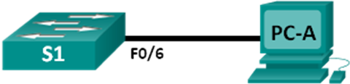

1. Addressing Table:

|  |  |  |  |
| --- | --- | --- | --- |
| Device | Interface | IP Address | Subnet Mask |
| S1 | VLAN 1 | 192.168.1.2 | 255.255.255.0 |
| PC-A | NIC | 192.168.1.10 | 255.255.255.0 |

Objectives:

* Build network to demonstrate remote switch management
* Complete in PT & physical devices
* Before attempting physical labs, sketch your configuration
* Do in PT first
* Work in groups for physical lab!
* Cisco switches have a special interface, known as a switch virtual interface (SVI). The SVI can be configured with an IP address, commonly referred to as the management address.
* The management address is used for remote access to the switch to display or configure settings.
* In this lab, you will build a simple network using Ethernet LAN cabling and access a Cisco switch using the console and remote access methods. You will configure basic switch settings, IP addressing, and demonstrate the use of a management IP address for remote switch management.
* The topology consists of one switch and one host using only Ethernet and console ports.

|  |  |  |
| --- | --- | --- |
| **Lab** | **Lab** | **Instructor Signature** |
| Lab 2.4 | Packet Tracer Lab |  |
| Lab 2.4 | Physical Lab |  |

Lab Tasks:

**Part 1: Configure a Basic Network Device**

1. **Cable the network**
2. **Configure basic switch settings**
3. **Configure IP address on PC-A**

**Part 2: Verify & Test Network Connectivity**

1. **Display S1 device config**
2. **Test end-to-end connectivity**
3. **Test & verify remote management of S1**
4. **Save config file**

Lab Work:

**Part 1: Configure a Basic Network Device**

* Set up network & config basic device settings

1. **Cable the network**

* Cable the network as shown in the topology.
* Establish a console connection to the switch from PC-A.
* **Note**: Make sure that the switch has been erased and has no startup configuration.

1. **Configure basic switch settings**

* Configure hostname, and an IP address for the SVI. Assigning an IP address on the switch is only the first step. As the network administrator, you must specify how the switch will be managed. Telnet and SSH are two of the most common management methods. However, Telnet is a very insecure protocol. All information flowing between the two devices is sent in plaintext. Passwords and other sensitive information can be easily viewed if captured by a packet sniffer
* Enter privileged EXEC mode.

Switch> **enable**

Switch#

* Enter global configuration mode and assign the switch hostname.

Switch# **configure terminal**

Switch(config)# **hostname S1**

S1(config)#

* Configure the switch password access.

S1(config)# **enable secret class**

S1(config)#

* Prevent unwanted DNS lookups.

S1(config)# **no ip domain-lookup**

S1(config)#

* Configure a login MOTD banner.

S1(config)# **banner motd #**

Enter Text message. End with the character ‘#’.

**Unauthorized access is strictly prohibited. #**

* Verify your access setting by moving between modes.
* Use exit, end or CTRL-Z

S1(config)# **exit**

S1#

S1# **exit**

Unauthorized access is strictly prohibited.

S1>

* Return to privileged EXEC mode from user EXEC mode.

S1> **enable**

Password: **class**

S1#

**Note**: The password will not show up on the screen when entering.

* Enter global configuration mode to set the SVI IP address to allow remote switch management.

S1# **config t**

S1#(config)# **interface vlan 1**

S1(config-if)# **ip address 192.168.1.2 255.255.255.0**

S1(config-if)# **no shut**

S1(config-if)# **exit**

S1(config)#

* Restrict console port access. Default configuration is to allow all console connections with no password needed.

S1(config)# **line con 0**

S1(config-line)# **password cisco**

S1(config-line)# **login**

S1(config-line)# **exit**

S1(config)#

* Configure the VTY line for the switch to allow Telnet access. If you do not configure a VTY password, you will not be able to telnet to the switch.

S1(config)# **line vty 0 4**

S1(config-line)# **password cisco**

S1(config-line)# **login**

S1(config-line)# **end**

S1#

1. **Configure IP address on PC-A**

* Assign the IP address and subnet mask to the PC, as shown in the addressing table

**Part 2: Verify & Test Network Connectivity**

* Verify switch configuration, test connectivity, and remote switch management

1. **Display S1 device config**

* Issue the **show run** command to display and verify your switch configuration
* A sample configuration is shown below. The settings you configured are highlighted in yellow. The other configuration settings are IOS defaults.

S1# **show run**

Building configuration...

<output omitted>

!

hostname S1

!

enable secret 4 06YFDUHH61wAE/kLkDq9BGho1QM5EnRtoyr8cHAUg.2

!

!

no ip domain-lookup

!

interface Vlan1

ip address 192.168.1.2 255.255.255.0

!

banner motd ^C

Unauthorized access is strictly prohibited. ^C

!

line con 0

password cisco

login

line vty 0 4

password cisco

login

end

* Verify the status of your SVI management interface. Your VLAN 1 interface should be up/up and have an IP address assigned. Notice that switch port F0/6 is also up because PC-A is connected to it. Because all switch ports are initially in VLAN 1, by default, you can communicate with the switch using the IP address you configured for VLAN 1.

S1# **show ip interface brief**

Interface IP-Address OK? Method Status Protocol

Vlan1 192.168.1.2 YES manual up up

FastEthernet0/1 unassigned YES unset down down

FastEthernet0/2 unassigned YES unset down down

FastEthernet0/5 unassigned YES unset down down

FastEthernet0/6 unassigned YES unset up up

FastEthernet0/7 unassigned YES unset down down

FastEthernet0/24 unassigned YES unset down down

GigabitEthernet0/1 unassigned YES unset down down

GigabitEthernet0/2 unassigned YES unset down down

1. **Test end-to-end connectivity**

* Open a command prompt window (cmd.exe) on PC-A
* Verify the IP address of PC-A by using the **ipconfig /all** command. This command displays the PC hostname and the IPv4 address information. Ping PC-A’s address and the management address of S1.
* Ping the PC-A address first.
* Next ping the SVI management address of S1.

C:\Users\NetAcad> **ping 192.168.1.10**

C:\Users\NetAcad> **ping 192.168.1.2**

* Your output should be similar to the following screens:

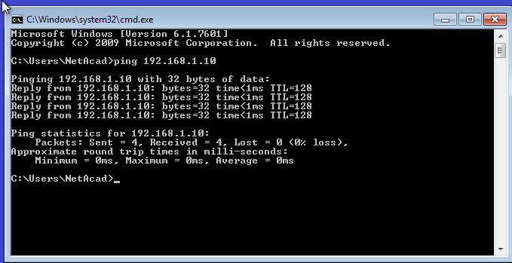

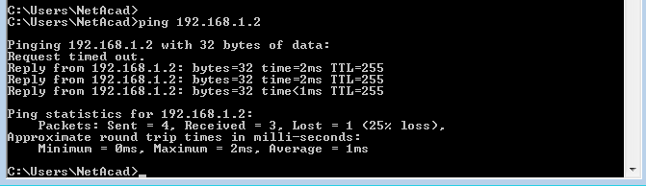

* If ping results are not successful, troubleshoot the basic device configurations. You should check both the physical cabling and IP addressing if necessary.

1. **Test & verify remote management of S1**

* You will use Telnet to remotely access the switch S1 using the SVI management address
* Telnet is not a secure protocol. However, you will use it in this lab to test remote access. All information sent by Telnet, including passwords and commands, is sent across the session in plaintext. In subsequent labs, you will use SSH to remotely access network devices
* **Note**: Windows 7 does not natively support Telnet. The administrator must enable this protocol. To install the Telnet client, open a command prompt window and type

C:\Users\NetAcad> **pkgmgr /iu:”TelnetClient”**

* With the command prompt window still open on PC-A, issue a Telnet command to connect to S1 via the SVI management address. The password is **cisco**.
* After entering the **cisco** password, you will be at the user EXEC mode prompt. Type **enable** at the prompt. Enter the **class** password to enter privileged EXEC mode and issue a **show run** command.

C:\Users\NetAcad> **telnet 192.168.1.2**

* Your output should be similar to the following screen:

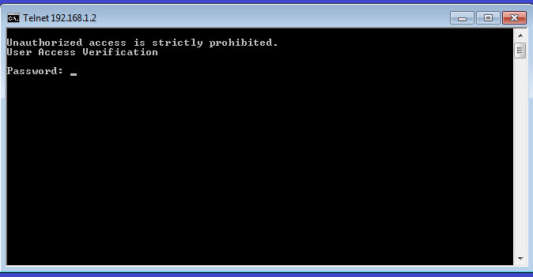

1. **Save config file**

* From your Telnet session, issue the **copy run start** command at the prompt.

S1# **copy run start**

Destination filename [startup-config]? **[Enter]**

Building configuration ..

S1#

* Exit Telnet by typing **quit**. You will be returned to the Windows 7 command prompt.
* Why must you use a console connection to initially configure the switch? Why not connect to the switch via Telnet or SSH?
* Instructor Sign-off: ___________________________ Date: _______________

# Chapter 3: Network Protocols & Communication

## Lab 3.1 Designing a Communications System

Objective:

* Explain the use of protocols & standards in facilitating interoperability in network communications
* Work in groups

Lab Tasks:

* You have just bought a new car. After a week it breaks down.
* You bring the car to the garage.
* Unfortunately, all the mechanics in this garage speak a different language to you
* However, you need to get the car fixed so you can drive home
* Design a communications system model to ensure your car is fixed

1. **Design Communications System**
2. **List Important Communications Steps**

Lab Work:

1. **Design Communications System**

* How can you communicate without a common language (medium of exchange)?

1. **List Important Communications Steps**

* What steps did you identify as important to communicating your repair request?
* To get you started, the first/last box have been filled in
* Remember, the ultimate goal is not just to get the car fixed, but to check it is working properly!

|  |  |  |
| --- | --- | --- |
| **Step#** | **Description** | **Example** |
| 1 | Choice of Medium | Sign Language |
| 2 | Explain Problem |  |
| 3 |  |  |
| 4 |  |  |
| 5 |  |  |
| … | Close the transaction | Pay for Repairs |

* Identify elements of the model that map to the Network Model (Application level, etc.)

|  |  |
| --- | --- |
| **Protocol** | **Mapping from Car Example** |
| Application Protocol | Establish a language to communicate |
| Transfer Protocol |  |
| Internet Protocol |  |
| Network Access Protocol |  |

## Lab 3.2 Researching Networking Standards

Objective:

* Identify roles of various networking standards organisations
* Discover how these standards lead to the development of Internet technologies
* Complete the table below in your own words:

|  |  |  |
| --- | --- | --- |
| **Acronym** | **Name** | **What They Do** |
| **ICANN** |  |  |
| **IANA** |  |  |
| **IETF** |  |  |
| **W3C** |  |  |
| **IEEE** |  |  |
| **WPA2** |  |  |
| **WiFi Alliance** |  |  |
| **ITU** |  |  |
| **EIA** |  |  |
| **ISOC** |  |  |
| **IAB** |  |  |
| **ISO** |  |  |
| **RFC** |  |  |

## Lab 3.3 Using Wireshark to View Network Traffic

Topology:

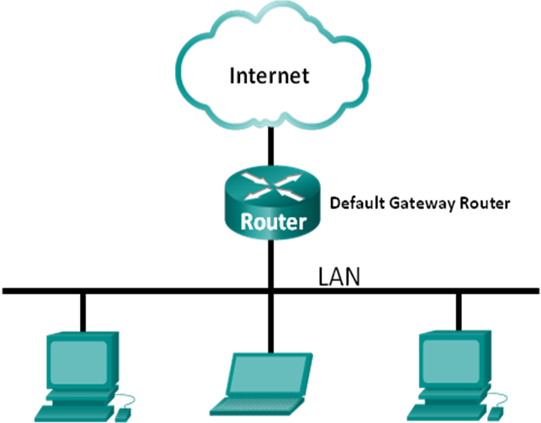

Objectives:

* Capture ICMP data packet IP addresses & Ethernet frame MAC addresses
* We will capture data local and remote to Lab303 network
* (We will NOT be using PT or physical devices in racks)
* Wireshark is a software protocol analyzer, or "packet sniffer" application, used for network troubleshooting, analysis, and education. As data streams travel back and forth over the network, the sniffer "captures" each protocol data unit (PDU) and can decode and analyze its content according to the appropriate RFC or other specifications
* It is a useful tool for anyone working with networks and can be used with most labs in the CCNA courses for data analysis and troubleshooting. In this lab, you will use Wireshark to capture ICMP data packet IP addresses and Ethernet frame MAC addresses

Lab Tasks:

**Part 1: Capture & Analyse Local ICMP Data in Wireshark**

1. **Retrieve your PC’s interface address**
2. **Start Wireshark & begin capturing data**
3. **Filter Wireshark Capture**
4. **Examine the captured data**

**Part 2: Capture & Analyse Remote ICMP Data in Wireshark**

1. **Start Wireshark & begin capturing data**
2. **Examine the captured data**

Lab Work:

**Part 1: Capture & Analyse Local ICMP Data in Wireshark**

* Ping another PC in your lab & capture ICMP requests & replies

1. **Retrieve your PC’s interface address**

* For this lab, you will need to retrieve your PC’s IP address and its network interface card (NIC) physical address, also called the MAC address.
* Open a command window, type **ipconfig /all**, and then press Enter.
* Write down your PC interface’s IP address and MAC (physical) address
* Note: we will be using the ITCARLOW NIC (not the CCNA NIC) throughout this lab

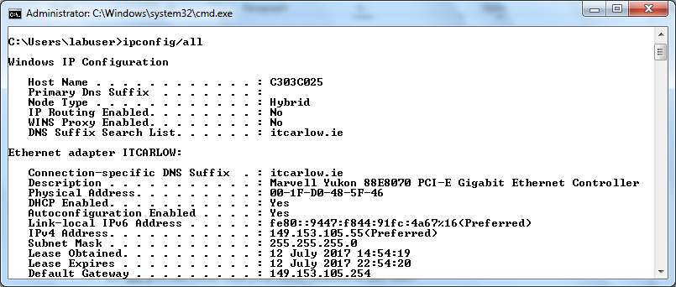

* Ask your neighbour for their PC’s IP address and provide your PC’s IP address to them
* Do not provide them with your MAC address at this time.

1. **Start Wireshark & begin capturing data**

* On your PC, open **Wireshark**
* After Wireshark starts, click **Interface List**
* On Wireshark: Capture Interfaces window, click the check box next to the IT Carlow LAN (NOT CCNA)
* Click **Start** to start the data capture.

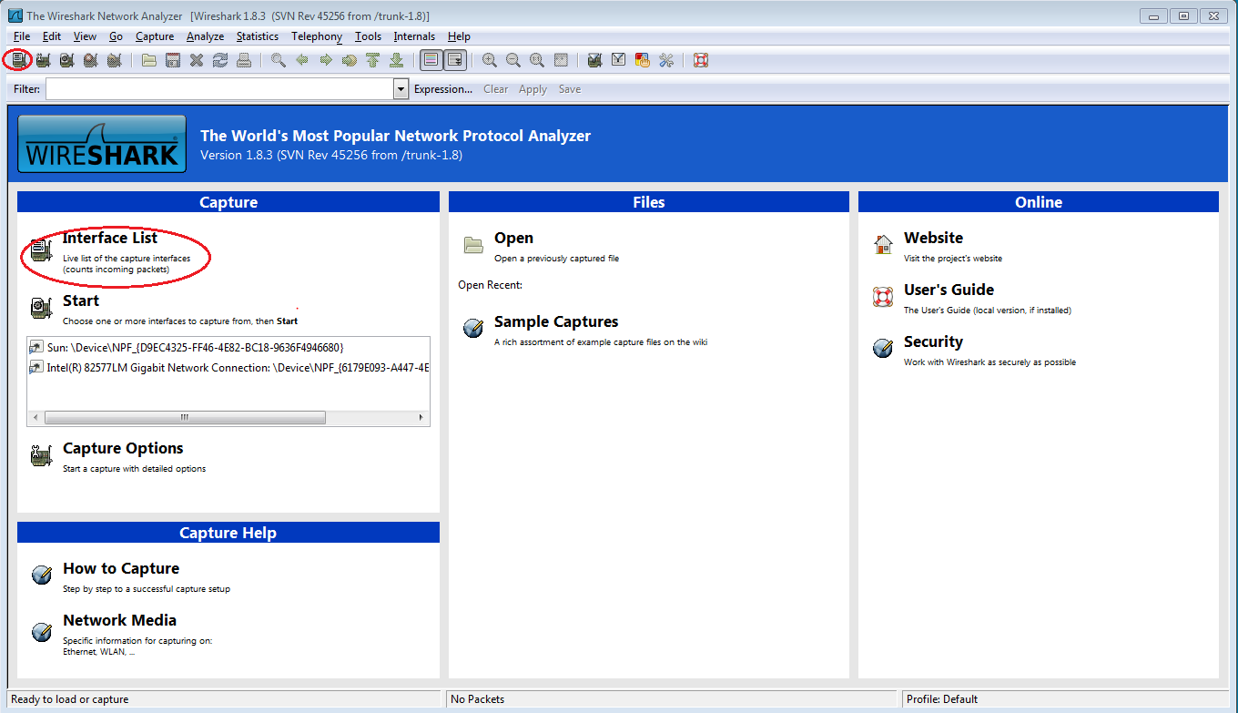

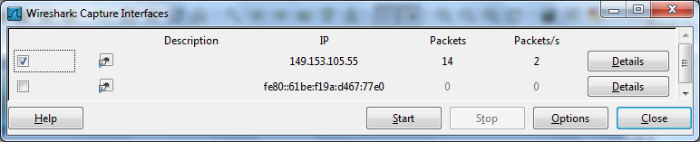

* Information will start scrolling down the top section in Wireshark. The data lines will appear in different colors based on protocol.

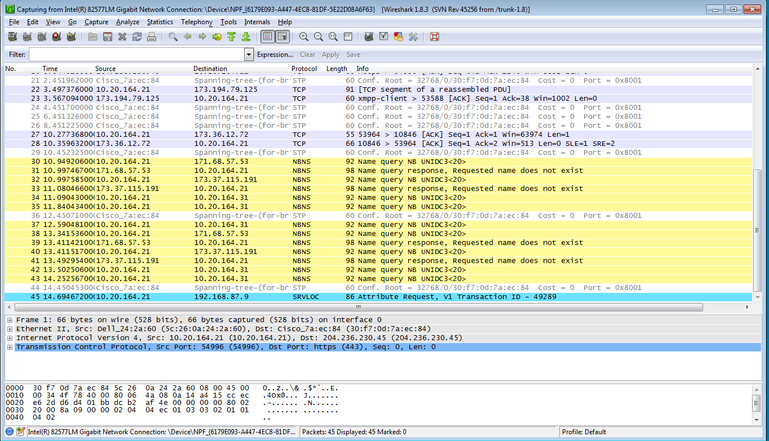

1. **Filter Wireshark Capture**

* Wireshark output can scroll by very quickly depending on what communication is taking place between your PC and the LAN. We can apply a filter to make it easier to view and work with the data that is being captured by Wireshark. For this lab, we are only interested in displaying ICMP (ping) PDUs.
* Type **icmp** in the Filter box at the top of Wireshark and press Enter or click on the **Apply** button to view only ICMP (ping) PDUs.

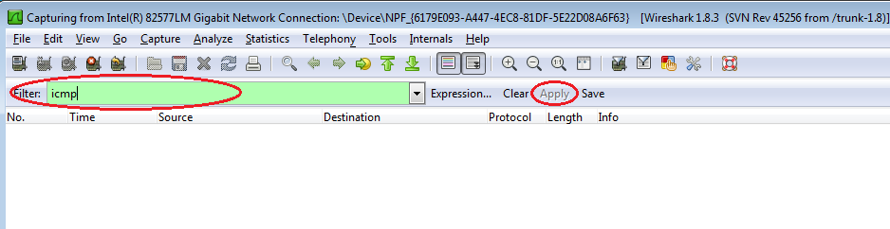

* This filter causes all data in the top window to disappear, but you are still capturing the traffic on the interface. Bring up the command prompt window that you opened earlier and ping the IP address that you received from your team member. Notice that you start seeing data appear in the top window of Wireshark again.

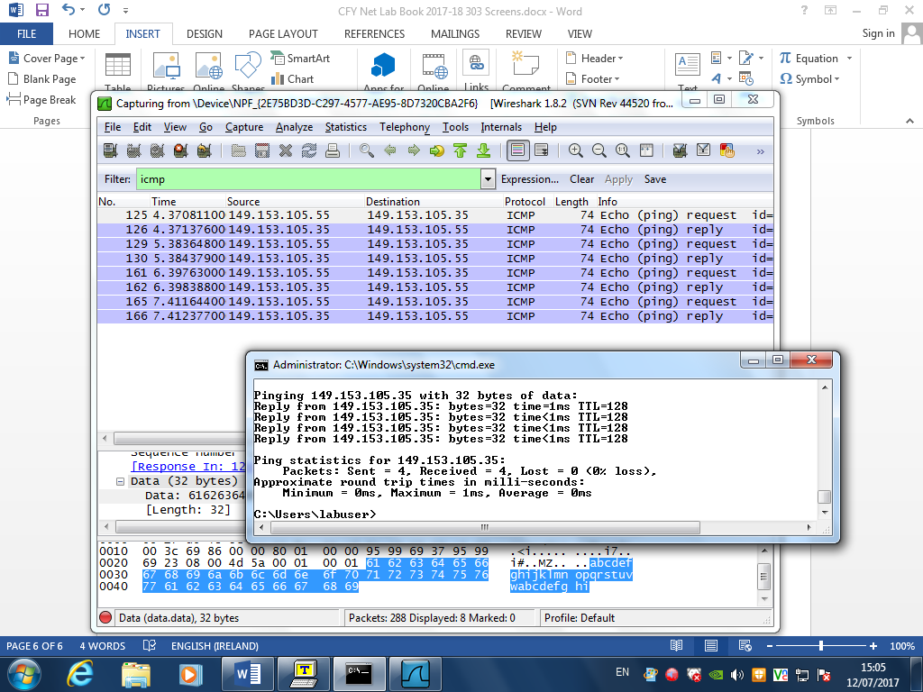

* **Note**: If your neighbour’s PC does not reply to your pings, this may be because their PC firewall is blocking these requests. Stop capturing data by clicking the **Stop Capture** icon.

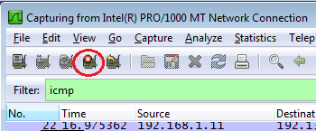

1. **Examine the captured data**

* Examine the data that was generated by the ping requests of your team member’s PC. Wireshark data is displayed in three sections: 1) The top section displays the list of PDU frames captured with a summary of the IP packet information listed, 2) the middle section lists PDU information for the frame selected in the top part of the screen and separates a captured PDU frame by its protocol layers, and 3) the bottom section displays the raw data of each layer. The raw data is displayed in both hexadecimal and decimal form.

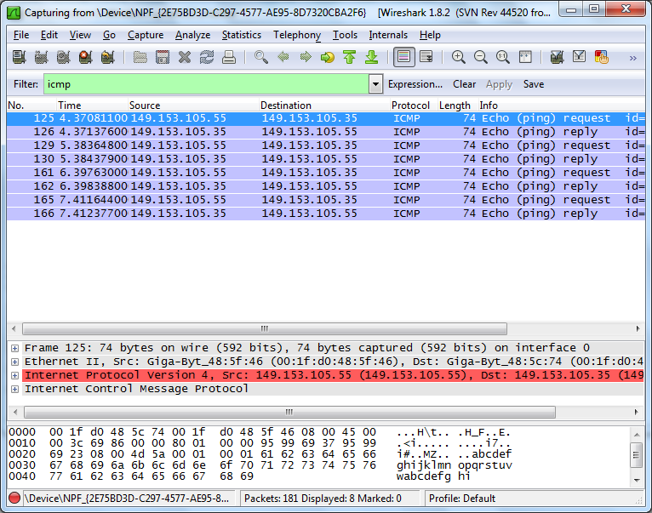

* Click the first ICMP request PDU frames in the top section of Wireshark. Notice that the Source column has your PC’s IP address & Destination has IP address of the teammate’s PC you pinged

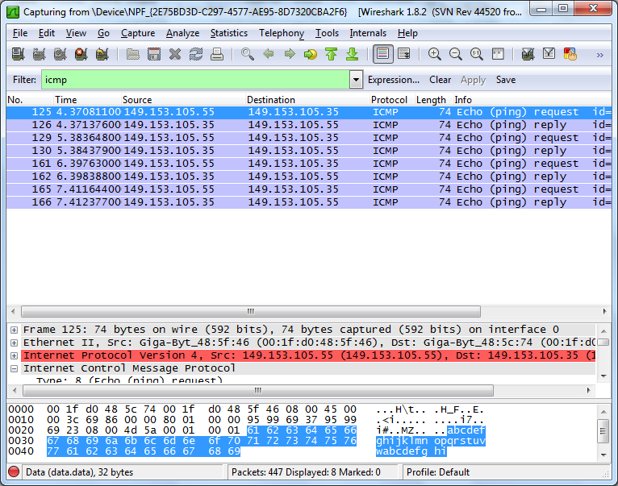

* With this PDU frame still selected in the top section, navigate to the middle section
* Click the plus sign to the left of the Ethernet II row to view the Destination & Source MAC addresses

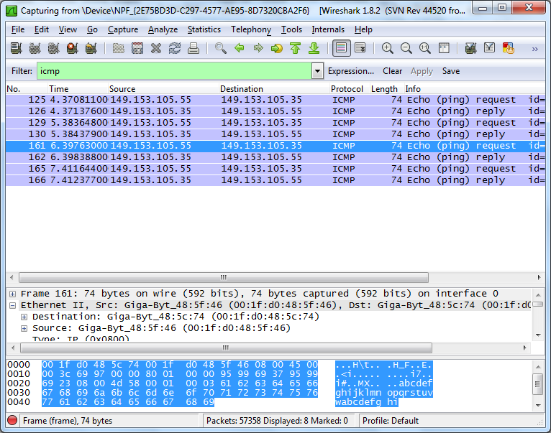

* Answer the questions below

|  |  |
| --- | --- |
| Does the Source MAC address match your PC’s interface? |  |
| Does the Destination MAC address in Wireshark match your team member’s MAC address? |  |
| How is the MAC address of the pinged PC obtained by your PC? |  |

* **Note**: In the preceding example of a captured ICMP request, ICMP data is encapsulated inside an IPv4 packet PDU (IPv4 header) which is then encapsulated in an Ethernet II frame PDU (Ethernet II header) for transmission on the LAN.

**Part 2: Capture & Analyse Remote ICMP Data in Wireshark**

* Ping remote hosts (not on your LAN) & capture ICMP requests & replies
* Determine the differences between this data and data from Part 1

1. **Start Wireshark & begin capturing data**

* Click the **Interface List** icon to bring up the list PC interfaces again.
* Make sure the check box next to the LAN interface is checked, and click **Start**.
* A window prompts to save the previously captured data before starting another capture. It is not necessary to save this data. Click **Continue without Saving**.

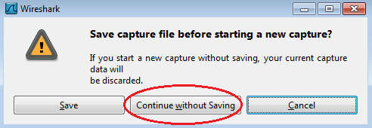

* With the capture active, ping the following three website URLs:
  + - 1. www.yahoo.com
      2. www.cisco.com
      3. [www.google.com](http://www.google.com)

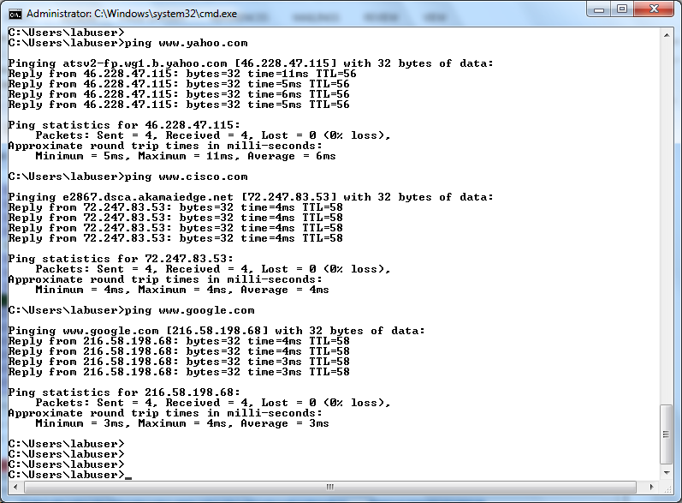

* **Note**: When you ping the URLs listed, notice that the Domain Name Server (DNS) translates the URL to an IP address. Note the IP address received for each URL.
* You can stop capturing data by clicking the **Stop Capture** icon.



1. **Examine the captured data**

* Review the captured data in Wireshark, examine the IP and MAC addresses of the three locations that you pinged
* List the destination IP and MAC addresses for all three locations in the space provided:

|  |  |  |  |  |
| --- | --- | --- | --- | --- |
| 1st Location | IP Address |  | MAC Address |  |
| 2nd Location | IP Address |  | MAC Address |  |
| 3rd Location | IP Address |  | MAC Address |  |

|  |  |
| --- | --- |
| What is significant about this information? |  |
| How does this information differ from the local ping information you received in Part 1? |  |
| Why does Wireshark show the actual MAC address of the local hosts, but not the actual MAC address for the remote hosts? |  |

* Instructor Sign-off: ___________________________ Date: _______________

# Chapter 4: Network Access

## Lab 4.1 Managing the Medium

Objectives:

* Understand the purpose of the data link layer
* Understand difficulty of communication if multiple nodes in a single domain need to communicate
* Work in groups
* You and your colleague attend a networking conference. There are many presentations held during this. Because they overlap, each of you can attend only a limited set of sessions. You split up, each of you attending a separate set of presentations
* When the event ends, you share the knowledge each of you gained during the event

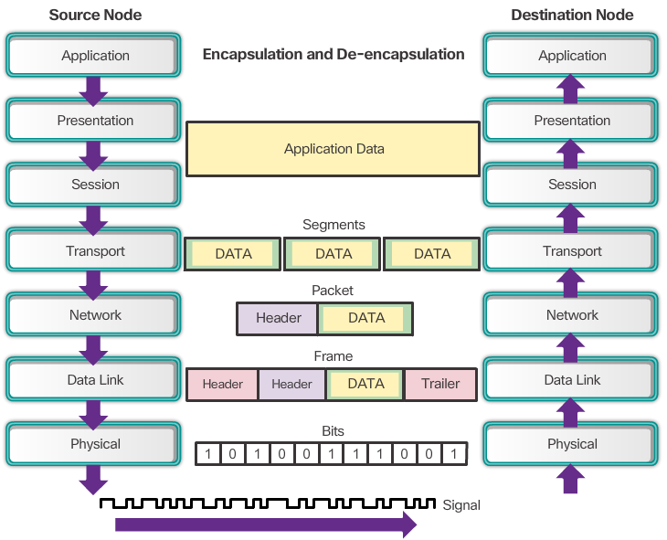

Lab Work:

1. How would you personally organize a conference where multiple sessions are held at the same time? Would you put all of them into a single conference room, or would you use multiple rooms? What would be the reason? Explain your answer.

I would organize a conference with multiple sessions in different rooms rather than in a single room. The reason for this is to prevent distractions and interference from other sessions, allowing each session to focus on its specific topic. Attendees can choose which session is most relevant to their interests, and separating sessions ensures that discussions, Q&A, and presentations are clear and specific to that audience.

1. The conference rooms are fitted with equipment to display video and amplify the speaker’s voice. If a person wanted to attend a specific session, does it matter which seat the person takes, or is it sufficient for the person to sit anywhere as long as it is in the appropriate conference room?

It generally doesn’t matter which specific seat a person takes, as long as they are in the appropriate room. With equipment to amplify sound and display visuals, everyone should be able to see and hear the presentation from any seat. However, if someone prefers to interact more (e.g., ask questions), they might prefer to sit closer to the front to engage with the speaker more easily.

1. What are the potential consequences or benefits if the speech from one conference room somehow leaked into another?

If sound from one conference room leaked into another, it could be distracting to both the speaker and the audience, leading to confusion or missed information. However, in rare cases, the content from one session could complement another, offering a benefit. Mostly though, it would cause noise pollution, reducing the effectiveness of both sessions.

1. If questions arise during a presentation, should an attendee simply shout out their question, or should there be some process of assuring that attendees are given an opportunity to ask questions that everyone can hear? What would happen without this process?

There should be a process for asking questions, such as using a microphone or raising hands. This ensures that everyone can hear the question and it is addressed properly. If attendees shout out questions without a process, it can disrupt the flow of the presentation, create confusion, and prevent others from hearing both the question and the response.

1. Can a session run out of time if, say, an interesting topic provokes many questions? If you did not want this to happen, what would be the best way to ensure that it does not occur?

Yes, a session can run out of time if discussions or questions go on for too long. To prevent this, time management is essential. The speaker or moderator can set clear time limits for each section of the presentation and Q&A, and politely manage overlong contributions. Using visual timers or announcing remaining time can also help keep the session on track.

1. Imagine that the session is in panel format, which allows more free discussion of attendees with the panellists and among themselves. If a person wants to address another person within the same room, can he/she do it directly? If so, how is this possible? How would a panellist invite another person to join who is not presently in the room?

In a panel format, attendees can directly address each other during discussions. This is facilitated by the open, conversational nature of the panel format, where communication between the audience and panellists is encouraged. To invite a person who isn’t in the room, the panellist might need to reference or mention them, suggesting that they join, perhaps by using an external communication method (e.g., calling or texting).

1. What benefit, if any, was achieved by the isolation of multiple sessions into separate conference rooms if, after the event, people could meet and share the information?

By isolating sessions into different rooms, attendees can focus on specific topics without distraction. After the event, sharing information can be beneficial as it encourages knowledge exchange between those who attended different sessions. However, the key benefit during the event is the ability to concentrate without interference.

1. Identify elements of the model that map to IT-related content. The first is done for you:

|  |  |
| --- | --- |
| Conference Room | Data –Link Layer domain,  Broadcast domain |
| Seat in a Conference Room | IP Addressing, specific node within a network |
| Questions, Enquiries | packets of information, data requests |
| Method of Asking a Question | **protocol** |
| Shouting in Conference Room | Broadcasting, flooding the network |

* Instructor Sign-off: ___________________________ Date: _______________

## Lab 4.2 Identifying Network Devices & Cabling

Lab Work:

**Part 1: Identify Network Devices**

* Work in pairs!
* Your instructor will provide various network devices for identification
* Fill in the table below with device manufacturer, device model, type (hub, switch, and router), functionality (wireless, router, switch, or combination), and other physical characteristics, such as number of interface types. First line is filled out as a reference.

|  |  |  |  |  |  |
| --- | --- | --- | --- | --- | --- |
| ID | Manufacturer | Model | Type | Functionality | Physical Characteristics |
| 1 | Cisco | 1941 | Router | Router | 2 GigabitEthernet Ports  2 EHWIC slots  2 CompactFlash slots  1 ISM slot  2 Console ports: USB, RJ-45 |
| 2 |  |  |  |  |  |
| 3 |  |  |  |  |  |
| 4 |  |  |  |  |  |
| 5 |  |  |  |  |  |
| 6 |  |  |  |  |  |

**Part 2: Identify Network Media**

* Your instructor will provide various network media for identification. You will name the network media, identify the media type (copper, fiber optic, or wireless), and provide a short media description including what device types it connects. Use the table below to record your findings. The first line in the table has been filled out as a reference.

|  |  |  |  |
| --- | --- | --- | --- |
| ID | Network Media | Type | Description and to What It Connects |
| 1 | UTP | Copper | Connect wired NIC and Ethernet ports on network devices  Cat 5 straight-through wired. Connects PCs and routers to switches and wiring panels. |
| 2 |  |  |  |
| 3 |  |  |  |
| 4 |  |  |  |
| 5 |  |  |  |
| 6 |  |  |  |

* Instructor Sign-off: ___________________________ Date: _______________

## Lab 4.3 Build an Ethernet Cable

1. Topology



1. Addressing Table

|  |  |  |  |  |
| --- | --- | --- | --- | --- |
| Device | Interface | IP Address | Subnet Mask | Default Gateway |
| PC-A | NIC | 192.168.10.1 | 255.255.255.0 | N/A |
| PC-B | NIC | 192.168.10.2 | 255.255.255.0 | N/A |

Objectives:

* In this lab, you will build & test an Ethernet cable. You will first analyze the Telecommunications Industry Association/Electronic Industries Association (TIA/EIA) 568-A & 568-B standards and how they apply to Ethernet cables. You will then construct an Ethernet crossover cable and test it. Finally, you will use the cable you just constructed to connect two PCs together and test it by pinging between them.
* **Note**: With autosensing capabilities available on many devices, such as the Cisco 1941 ISR switch, you may see straight-through cables connecting like devices.

Lab Tasks:

**Part 1: Use Ethernet Cables in Packet Tracer**

1. **Connect PCs using ST/XO cables**

**Part 2: Analyze Ethernet Cabling Standards and Pinouts**

1. **Analyze diagrams and tables for the TIA/EIA 568-A/B standard Ethernet cable**

**Part 3: Build an Ethernet Crossover Cable**

1. **Build & terminate a TIA/EIA 568-A cable end**
2. **Build & terminate a TIA/EIA 568-B cable end**

**Part 4: Test the Cable**

1. **Test the Ethernet crossover cable with a cable tester**
2. **Connect two PCs together using your Ethernet crossover cable**

* **Required Resources**:
* One length of cable, either Category 5 or 5e. Cable length should be 0.6 to 0.9m
* 2 RJ-45 connectors, RJ-45 crimping tool, Wire cutter, Wire stripper
* Ethernet cable tester
* Useful YouTube Videos:

[http://www.youtube.com/watch?v=jcJ932W4hac](https://mail.itcarlow.ie/owa/redir.aspx?C=0671206392b94ef4993427a4d729919a&URL=http%3a%2f%2fwww.youtube.com%2fwatch%3fv%3djcJ932W4hac)     (9 mins)  
http://www.youtube.com/watch?v=98-B3JoGr_k    (10 mins)

Lab Work:

**Part 1: Use Ethernet Cables in Packet Tracer**

* Use PT to show how Straight Through (ST) & Crossover (XO) cables work

1. **Connect PCs using ST/XO cables**

* Use PT to show how Straight Through (ST) & Crossover (XO) cables work

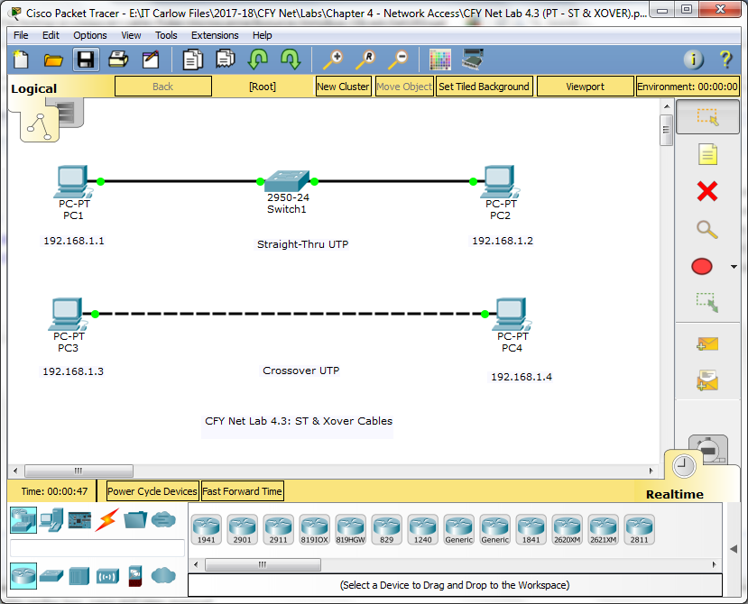

**Part 2: Analyze Ethernet Cabling Standards and Pinouts**

1. **Analyze diagrams and tables for the TIA/EIA 568-A/B standard Ethernet cable**

* The following tables and diagrams display the colour scheme and pinouts, as well as the function of the four pairs of wires used for the 568-A & 568-B standard.
* **Note**: In LAN installations using 100Base-T only two pairs out of the four are used
* Note: in crossover cable, wires 1,2,3,6 are swapped, wires 4,5,7,8 are the same!

**568-A 10/100/1000Base-TX Ethernet**

|  |  |  |  |  |
| --- | --- | --- | --- | --- |
| Pin Number | Pair Number | Wire Color | 10Base-T Signal 100Base-TX Signal | 1000Base-T Signal |
| **1** | **2** | **White/Green** | **Transmit** | **BI_DA+** |
| **2** | **2** | **Green** | **Transmit** | **BI_DA-** |
| **3** | **3** | **White/Orange** | **Receive** | **BI_DB+** |
| **4** | **1** | **Blue** | **Not Used** | **BI_DC+** |
| **5** | **1** | **White/Blue** | **Not Used** | **BI_DC-** |
| **6** | **3** | **Orange** | **Receive** | **BI_DB-** |
| **7** | **4** | **White/Brown** | **Not Used** | **BI_DD+** |
| **8** | **4** | **Brown** | **Not Used** | **BI_DD-** |

**568-B 10/100/1000-BaseTX Ethernet**

|  |  |  |  |  |
| --- | --- | --- | --- | --- |
| Pin Number | Pair Number | Wire Color | 10Base-T Signal 100Base-TX Signal | 1000Base-T Signal |
| **1** | **2** | **White/Orange** | **Transmit** | **BI_DA+** |
| **2** | **2** | **Orange** | **Transmit** | **BI_DA-** |
| **3** | **3** | **White/Green** | **Receive** | **BI_DB+** |
| **4** | **1** | **Blue** | **Not Used** | **BI_DC+** |
| **5** | **1** | **White/Blue** | **Not Used** | **BI_DC-** |
| **6** | **3** | **Green** | **Receive** | **BI_DB-** |
| **7** | **4** | **White/Brown** | **Not Used** | **BI_DD+** |
| **8** | **4** | **Brown** | **Not Used** | **BI_DD-** |

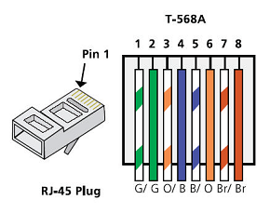

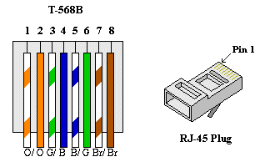

**Part 3: Build the Ethernet Crossover Cable**

* A crossover cable has the second and third pairs on the RJ-45 connector at one end, reversed at the other end. The cable pinouts are the 568-A standard on one end and the 568-B standard on the other end. The two following diagrams illustrate this concept.

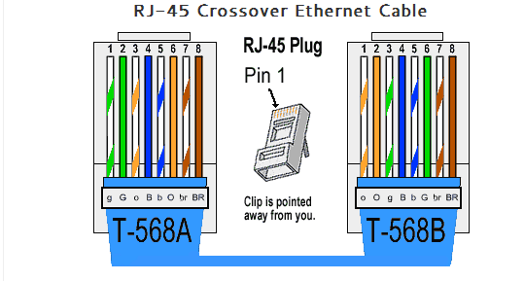

**[One End of Cable] [Other End of Cable]**

1. **Build & terminate a TIA/EIA 568-A cable end**
2. Cut off a piece of cable to the desired length
3. Using your wire stripper, remove 5 cm (2 in.) of the cable jacket from both ends
4. Hold the four pairs of twisted cables tightly where the jacket was cut away. Reorganize the cable pairs into the order of the 568-A wiring standard. Refer to the diagrams
5. Maintain the twists in the cable (this provides noise cancellation)
6. Flatten, straighten, and line up the wires using your thumb and forefinger
7. Ensure that the cable wires are still in the correct order for the 568-A standard.
8. Using wire cutters, trim the four pairs in a straight line to within 1.25 to 1.9 cm (1/2 to 3/4 in.)
9. Place an RJ-45 connector on the end of your cable, with the prong on the underside pointing downward. Firmly insert the wires into the RJ-45 connector. All wires should be seen at the end of the connector in their proper positions
10. If the wires are not extending to the end of the connector, take the cable out, rearrange the wires as necessary, and reinsert the wires back into the RJ-45 connector.
11. If everything is correct, insert the RJ-45 connector with cable into the crimper. Crimp down hard enough to force the contacts on the RJ-45 connector through the insulation on the wires, thus completing the conducting path.
12. **Build & terminate a TIA/EIA 568-B cable end**

* Repeat Step 1, this time using the 568-B colour-wiring scheme for the other end.

**Part 4: Test the Cable**

1. **Test your Ethernet crossover cable with a cable tester**
2. Many cable testers will test for length and mapping of wires. If the cable tester has a wire map feature, it verifies which pins on one end of the cable are connected to which pins on the other end.
3. Plug both ends of cable into the cable tester & press **MODE** button
4. Top line should read: **36 12 45 78**
5. If it fails, check with your instructor first as to whether you should re-cable the ends and re-test.

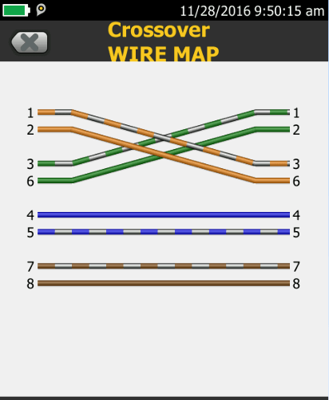

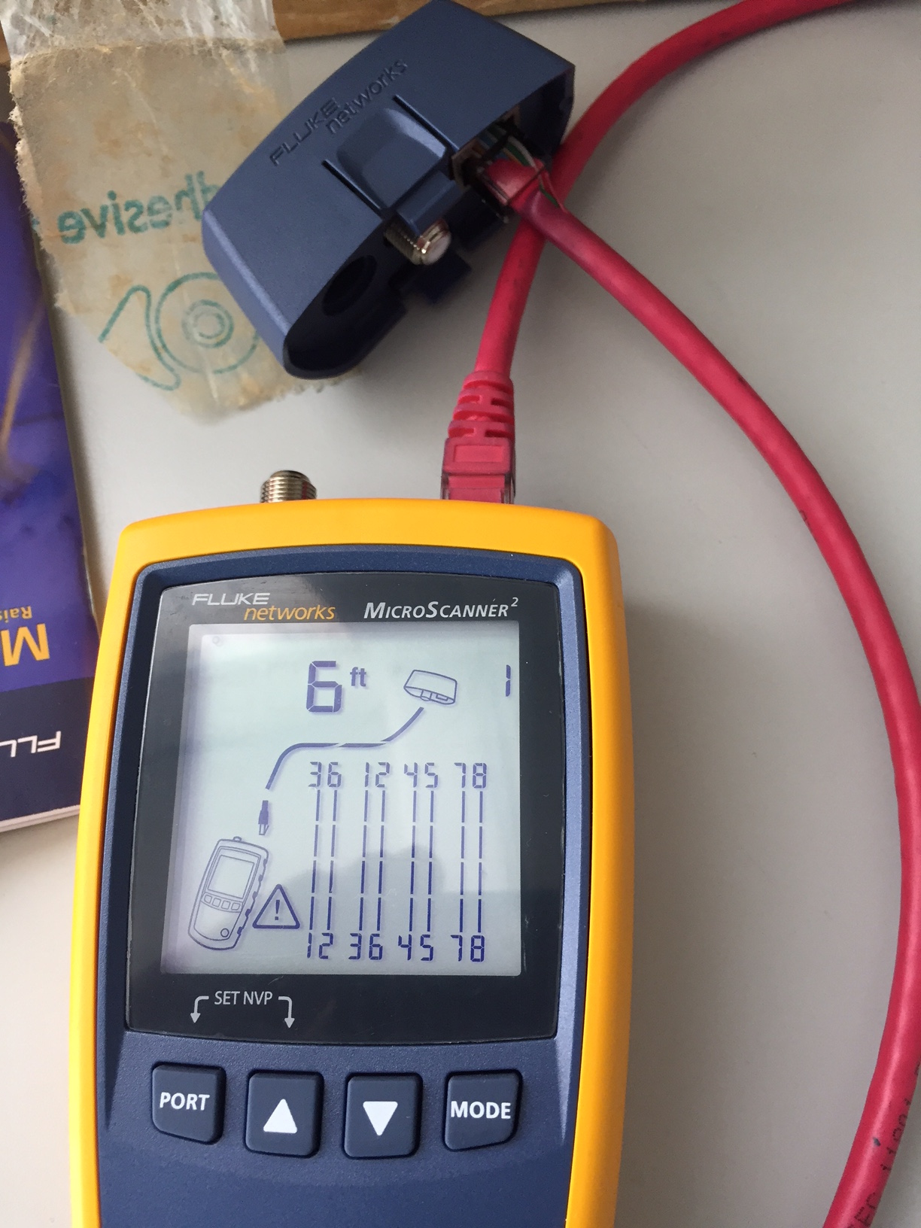

1. **Connect two PCs together using your Ethernet crossover cable**
2. Working with a lab partner, set your PC to one of the IP addresses shown in the Addressing Table. For example, if your PC is **PC-A**, your IP address should be set to **192.168.10.1** with a **24-bit subnet mask**. You partner’s IP address should be **192.168.10.2**. The default gateway address can be left empty.
3. Using the crossover cable you made, connect the two PCs together via their NICs.
4. On the PC-A command prompt, ping the PC-B IP address.
5. The Windows firewall may have to be temporarily disabled for pings to be successful. If the firewall is disabled, make sure you re-enable it at the conclusion of this lab.
6. Repeat the process and ping from PC-B to PC-A
7. Assuming IP addressing and firewall are not issues, your pings should be successful if the cables were properly made.
8. Note: Why do you have to learn how to make a cable if you can easily buy pre-made cables?
9. Extra: Connect 2 PCs using xover cable. Ping & share folders, etc.

* Instructor Sign-off: ___________________________ Date: _______________

## Lab 4.4 Viewing Wired & Wireless NIC Info

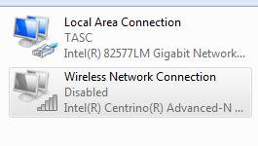

Objectives:

* This lab requires you to determine the availability and status of the network interface cards (NICs) on the PC that you use. Windows provides a number of ways to view and work with your NICs.
* (We will NOT be using PT or physical devices in racks)
* You will access the NIC information of your PC and change the status of these cards
* **Note**: If the wired and wireless NICs are both enabled the PC will receive two different IP addresses and the wireless NIC will take precedence.

Lab Tasks:

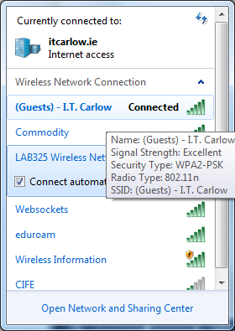**Part 1: Install WNIC**

1. **Install WNIC Software**
2. **Connect to IT Carlow Wi-Fi**

**Part 2: Identify & Work with PC NICs**

1. **Open Network & Sharing Centre**
2. **Work with your Wireless NIC**
3. **Work with your Wired NIC**

**Part 3: Identify & Use the System Tray Network Icons**

1. **Use the Wireless Network Icon**
2. **Use the Wired Network Icon**
3. **Identify the Network Problem Icon**

Lab Work:

**Part 1: Install WNIC**

* We will use a USB wireless network adapter for this part of the lab

1. **Install WNIC Software**

* Insert CD [Linksys USB]
* Click on “Install Linksys Adapter” (patience!)
* Insert Wireless USB when requested (quite slow!)

1. **Connect to IT Carlow Wi-Fi**

* Connect to (Guests) IT Carlow Wi-Fi (get password from instructor)

**Part 2: Identify & Work with PC NICs**

* You will identify the NIC types in the PC that you are using.
* You will explore different ways to extract information about these NICs and how to activate and deactivate them.

1. **Open Network & Sharing Centre**

* Open the **Network and Sharing Center** by clicking Windows **Start** button > **Control Panel** > **View network status and tasks** under Network and Internet heading in the Category View
* In the left pane, click the **Change adapter settings** link.
* **Network Connections** window opens, which provides list of NICs available on this PC. Look for your Local Area Connection & Wireless Network Connection adapters here
* **Note**: Virtual Private Network (VPN) adapters and other types of network connections may also be displayed in this window. Ignore them

1. **Work with your Wireless NIC**
2. Select the **Wireless Network Connection** option and right-click it to bring up a drop-down list. If your **Wireless Network Connection** is currently disabled, then click **Enable**
3. Right-click the **Wireless Network Connection**, and click **Status**.

This should display information about your wireless connection.

1. Click **Details** to display the Network Connection Details window

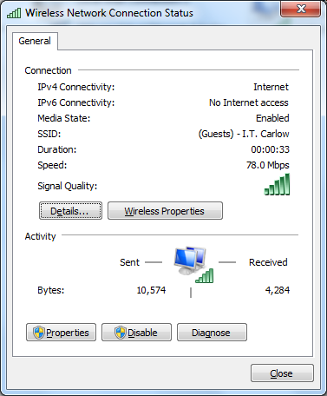

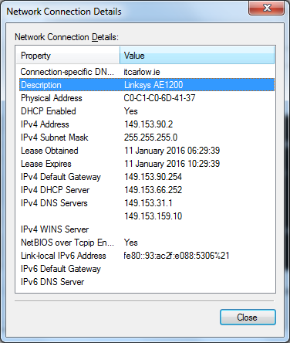

1. Complete the table below

|  |  |
| --- | --- |
| **SSID (Service Set Identifier) for the wireless router for your connection** |  |
| **Speed of your wireless connection** |  |
| **MAC address of your wireless NIC** |  |
| **Do you have multiple IPv4 DNS Servers listed?** |  |
| **Why would multiple DNS Servers be listed?** |  |

1. When you have reviewed the network connection details, click **Close**.
2. Open a command window prompt and type **ipconfig /all**.
3. Notice that the info displayed here is the same info that was displayed in the Network Connection Details window above

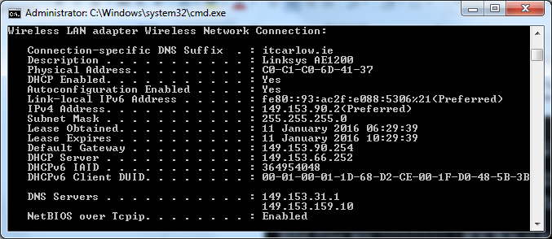

1. **Work with your Wired NIC**
2. On the Network Connections window, select and right-click the **Local Area Connection** option to display the drop-down list. If NIC is disabled, enable it, and click **Status** option
3. The Local Area Connection Status window will open. This window displays information about your wired connection to the LAN.

Click **Details…** to view the address information for your LAN connection.

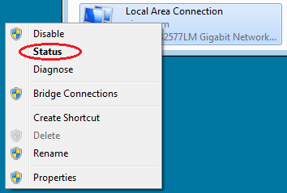

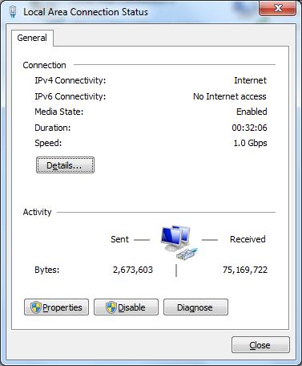

\

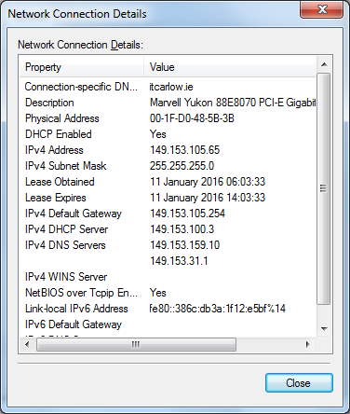

1. Open a command window prompt and type **ipconfig /all**. Find your LAN info and compare this with the info displayed in the Network Connection Details window.
2. Close all windows on your desktop before moving to next part

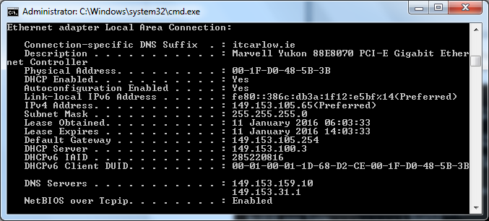`

**Part 3: Identify & Use the System Tray Network Icons**

* 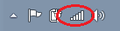In Part 3, you will use the network icons in your system tray to determine and control the NICs on your PC.

1. **Use the Wireless Network Icon**
2. Click the system tray **Wireless Network** icon to view the pop-up window that displays the SSIDs that are in-range of your wireless NIC. When the system tray displays the Wireless Networkicon, the wireless NIC is active
3. Click the **Open Network and Sharing Center** link. **Note:** This is a shortcut way to bring up this window
4. In left pane, click **Change adapter settings** to display the Network Connections window
5. Select & right-click **Wireless Network Connection**, then click **Disable** to disable your WNIC
6. Examine your system tray. The **Wireless Network Connection** icon should be replaced by the **Wired Network** icon. This indicates that you are using your wired NIC for network connectivity.
7. **Note**: If both NICs are active, the **Wireless Network** icon is the one that is displayed.

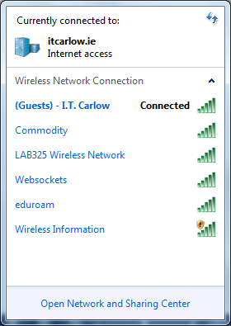

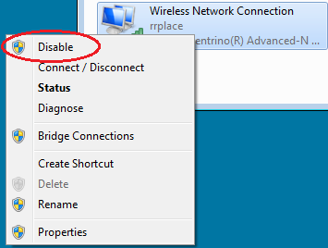



1. **Use the Wired Network Icon**
2. Click the **Wired Network** icon. Notice that the Wireless SSIDs are no longer displayed in this pop-up window, but you still have the ability to get to the Network and Sharing Center window from here.
3. Click the **Open Network and Sharing Center** link > **Change adapter settings** and **Enable** your **Wireless Network Connection**. The **Wireless Network** icon should replace the **Wired Network** icon in your system tray.

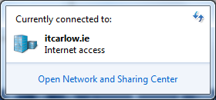

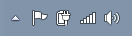

1. **Identify the Network Problem Icon**
2. On the Network Connections window, disable both the **Wireless Network Connection** and the **Local Area Connection**
3. The system tray now displays the **Network Disabled** icon, which indicates that network connectivity has been disabled
4. You can click this icon to return to the Network and Sharing Center window (examine the network diagram at the top).

You can click the red **X** to have the PC troubleshoot the problem with the network connection. Troubleshooting attempts to resolve the network issue for you

1. If troubleshooting did not enable one of your NICs, then you should do this manually to restore the network connectivity of your PC

**Note**: If a network adapter is enabled and the NIC is unable to establish network connectivity, then the **Network Problem** icon appears in the system tray.





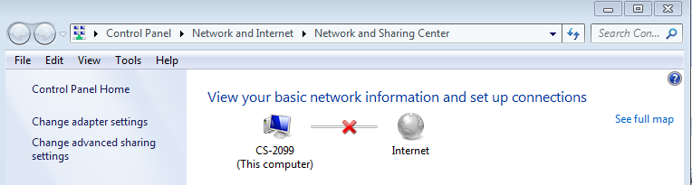

|  |  |
| --- | --- |
| **Why would you activate more than one NIC on a single PC?** |  |

* Instructor Sign-off: ___________________________ Date: _______________

## Lab 4.5 Connecting g Wired & Wireless Nets (PT)

Objective:

* This activity will examine device configurations in Packet Tracer, selecting the proper cable based on the configuration, and connecting the devices.
* This activity will also explore the physical view of the network in Packet Tracer
* N.B. Connection from Router1 to Switch is fiber!!

Topology

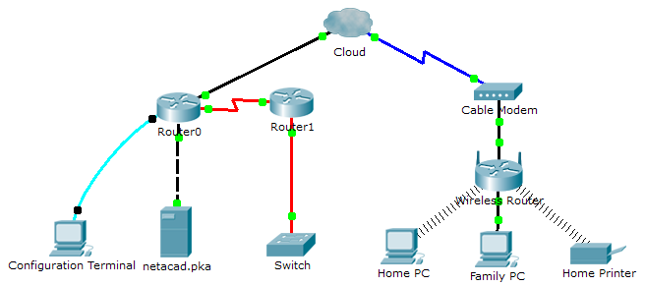

Addressing Table

|  |  |  |  |
| --- | --- | --- | --- |
| **Device** | **Interface** | **IP Address** | **Connects To** |
| Cloud | Eth6 | N/A | F0/0 |
|  | Coax7 | N/A | Port0 |
| Cable Modem | Port0 | N/A | Coax7 |
|  | Port1 | N/A | Internet |
| Router0 | Console | N/A | RS232 |
|  | F0/0 | 192.168.2.1/24 | Eth6 |
|  | F0/1 | 10.0.0.1/24 | F0 |
|  | Ser0/0/0 | 172.31.0.1/24 | Ser0/0 |
| Router1 | Ser0/0 | 172.31.0.2/24 | Ser0/0/0 |
|  | F1/0 | 172.16.0.1/24 | F0/1 |
| WirelessRouter | Internet | 192.168.2.2/24 | Port 1 |
|  | Eth1 | 192.168.1.1 | F0 |
| Family PC | F0 | 192.168.1.102 | Eth1 |
| Switch | F0/1 | 172.16.0.2 | F1/0 |
| netacad.pka | F0 | 10.0.0.254 | F0/1 |
| Configuration Terminal | F0 | 10.0.0.254 | F0/1 |

Lab Tasks:

**Part 1:Connect to the Cloud**

1. **Connect the Cloud to Router0**
2. **Connect the Cloud to Cable Modem**

**Part 2:Connect Router0**

1. **Connect Router0 to Router1**
2. **Connect Router0 to netacad.pka**
3. **Connect Router0 to the Configuration Terminal**

**Part 3:Connect Remaining Devices**

1. **Connect Router1 to Switch**
2. **Connect Cable Modem to Wireless Router**
3. **Connect Wireless Router to Family PC**

**Part 4:Verify Connections**

1. **Test Connection from Family PC to netacad.pka**
2. **Ping the Switch from HOME PC**
3. **Open Router0 from Configuration Terminal**
4. **Check your score**

**Part 5: Examine the Physical Topology [Optional]**

1. **Examine the Cloud**
2. **Examine the Primary Network**
3. **Examine the Secondary Network**
4. **Examine the Home Network**

Lab Work:

* Download the PKA file from Blackboard (4.5 Connecting a Wired and Wireless LAN.pka)
* Open the file with Packet Tracer & follow instructions below
* Save your work with same lab name plus your name (e.g. Lab 4.5 PH.pka)

**Part 1:Connect to the Cloud**

1. **Connect the Cloud to Router0**

* At bottom left, click the orange lightning icon to open the available Connections.
* Choose the correct cable to connect **Router0 F0/0** to **Cloud Eth6**.
* **Cloud** is a type of switch, so use a **Copper Straight-Through** connection
* If you attached the correct cable, the link lights on the cable turn green.

1. **Connect the Cloud to Cable Modem**

* Choose the correct cable to connect **Cloud Coax7** to **Cable Modem Port0**.
* If you attached the correct cable, the link lights on the cable turn green.

**Part 2:Connect Router0**

1. **Connect Router0 to Router1**

* Choose the correct cable to connect **Router0 Ser0/0/0** to **Router1 Ser0/0**
* Use one of the available serial cables
* If you attached the correct cable, the link lights on the cable turn green.

1. **Connect Router0 to netacad.pka**

* Choose the correct cable to connect **Router0 F0/1** to **netacad.pka F0**
* Routers and computers traditionally use the same wires to transmit (1 and 2) and receive (3 and 6). The correct cable to choose consists of these crossed wires. Although many NICs can now autosense which pair is used to transmit and receive, **Router0** and **netacad.pka** do not have autosensing NICs.
* If you attached the correct cable, the link lights on the cable turn green

1. **Connect Router0 to the Configuration Terminal**

* Choose the correct cable to connect **Router0 Console** to **Configuration Terminal RS232**. This cable does not provide network access to **Configuration Terminal**, but allows you to configure **Router0** through its terminal.
* If you attached the correct cable, the link lights on the cable turn black

**Part 3:Connect Remaining Devices**

1. **Connect Router1 to Switch**

* This is a fiber connection
* Choose the correct cable to connect **Router1 F1/0** to **Switch F0/1**
* If you attached the correct cable, the link lights on the cable turn green
* Allow a few seconds for the light to transition from amber to green

1. **Connect Cable Modem to Wireless Router**

* Choose the correct cable to connect **Cable Modem Port1** to **Wireless Router Internet** port
* If you attached the correct cable, the link lights on the cable will turn green.

1. **Connect Wireless Router to Family PC**

* Choose the correct cable to connect **Wireless Router Ethernet 1** to **Family PC**.
* If you attached the correct cable, the link lights on the cable turn green

**Part 4:Verify Connections**

1. **Test Connection from Family PC to netacad.pka**

* Open the **Family PC** command prompt and ping **netacad.pka**
* Open the **Web Browser** and the web address **http://netacad.pka**

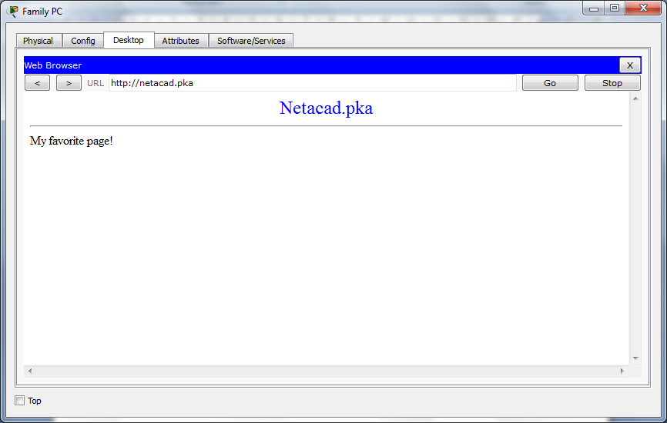

1. **Ping the Switch from HOME PC**

* Open the **Home PC** command prompt and ping the **Switch** IP address of to verify the connection

1. **Open Router0 from Configuration Terminal**

* Open the **Terminal** of **Configuration Terminal** and accept the default settings
* Press **Enter** to view the **Router0** command prompt
* Type **show ip interface brief** to view interface statuses

1. **Check your score**

* Open PT Activity window & click **Check Results** box

**Part 5: Examine the Physical Topology [Optional!]**

1. **Examine the Cloud**

* Click the **Physical Workspace** tab or press **Shift**+**P** and **Shift**+**L** to toggle between the logical and physical workspaces.
* Click the **Home City** icon.
* Click the **Cloud** icon. How many wires are connected to the switch in the blue rack? 2
* Click **Back** to return to **Home City**.

1. **Examine the Primary Network**

* Click the **Primary Network** icon. Hold the mouse pointer over the various cables. What is located on the  table to the right of the blue rack?
* Click **Back** to return to **Home City**.

1. **Examine the Secondary Network**

* Click the **Secondary Network** icon. Hold the mouse pointer over the various cables. Why are there two  orange cables connected to each device?
* Click **Back** to return to **Home City**.

1. **Examine the Home Network**

* Why is there an oval mesh covering the home network?
* Click the **Home Network** icon. Why is there no rack to hold the equipment?
* Click the **Logical Workspace** tab to return to the logical topology
* Instructor Sign-off: ___________________________ Date: _______________

## Lab 4.6 Linked In (Cabling Technology)

Objectives:

* Connect devices using wired and wireless media.
* Students will map their cabling ideas to a physical topology
* No logical (IP) addressing needed

1. Physical Topology

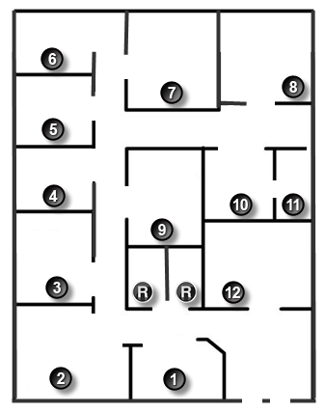

1. Background /Scenario

* **Note**: This activity is best completed in groups of 2-3 students.
* Your small business is moving to a new location. Your building is brand new, and you must come up with a physical topology so that network port installation can begin.
* Use the blueprint above. The area on the blueprint, indicated by Number 1, is the reception area and the area numbered RR is the restroom area.
* All rooms are within Category 6 UTP specifications (100 meters), so you have no concerns about hard-wiring the building to code. Each room in the diagram must have at least one network connection available for users/intermediary devices.
* Do not go into excessive detail on your design. Just use the content from the chapter to be able to justify your decisions to the class.

Lab Work:

**Design a Physical Network Topology**

* Choose & decide placement of networking devices & cabling
* Answer the questions below:

|  |  |
| --- | --- |
| 1. **Where would you locate your network main distribution facility, while keeping security in mind?** |  |
| 1. **How many intermediary devices you would use and where would you place them?** |  |
| 1. **What kind of cabling you would use (UTP, STP, wireless, fiber optics, etc.) and where would the ports be placed** |  |
| 1. **What types of end devices you would use (wired, wireless, laptops, desktops, tablets, etc.)?** |  |

* Instructor Sign-off: ___________________________ Date: _______________

# Chapter 5: Ethernet

## Lab 5.1 Use Wireshark to Examine Ethernet Frames

1. Topology

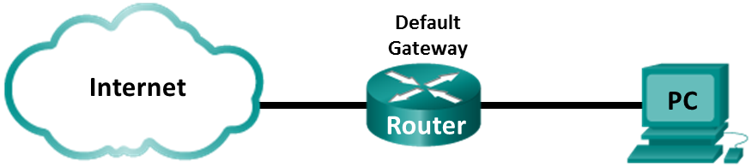

Background/Objectives:

* When upper layer protocols communicate with each other, data flows down the OSI layers and is encapsulated into a Layer 2 frame
* The frame composition is dependent on the media access type
* For example, if the upper layer protocols are TCP & IP and the media access is Ethernet, then the Layer 2 frame encapsulation will be Ethernet II. This is typical for a LAN environment
* When learning about Layer 2 concepts, it is helpful to analyze frame header information. In the first part of this lab, you will review the fields contained in an Ethernet II frame.
* In Part 2, you will use Wireshark to capture and analyze Ethernet II frame header fields for local and remote traffic.
* Note: Use IT Carlow LAN,
* (We will NOT be using PT or physical devices in racks)

Lab Tasks:

**Part 1: Examine the Header Fields in an Ethernet II Frame**

1. **Review the Ethernet II header field descriptions and lengths**
2. **Examine the network configuration of the PC**
3. **Examine Ethernet frames in a Wireshark capture**
4. **Examine the Ethernet II header contents of an ARP request.**

**Part 2: Use Wireshark to Capture and Analyze Ethernet Frames**

1. **Determine the IP address of the default gateway on your PC**
2. **Start capturing traffic on your PC’s NIC**
3. **Filter Wireshark to display only ICMP traffic.**
4. **From the command prompt window, ping the default gateway of your PC.**
5. **Stop capturing traffic on the NIC**
6. **Examine the first Echo (ping) request in Wireshark**
7. **Restart packet capture in Wireshark**
8. **Capture Remote Ethernet Frames**

Lab Work:

**Part 1: Examine the Header Fields in an Ethernet II Frame**

* This part does **NOT** require network access.
* Just study the figures below & answers the questions at the end
* Examine the header fields and content in an Ethernet II Frame
* A sample Wireshark capture will be used to examine the contents in those fields.

1. **Review the Ethernet II header field descriptions and lengths**

* Examine table below for makeup of Ethernet II frame

|  |  |  |  |  |  |
| --- | --- | --- | --- | --- | --- |
| Preamble | Destination Address | Source Address | Frame Type | Data | FCS |
| 8 Bytes | 6 Bytes | 6 Bytes | 2 Bytes | 46 – 1500 Bytes | 4 Bytes |

1. **Examine the network configuration of the sample PC**

* This PC host IP address is 192.168.1.17 and the default gateway has an IP address of 192.168.1.1

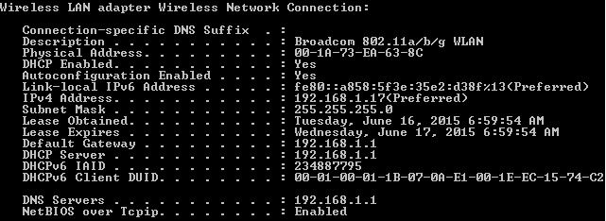

1. **Examine Ethernet frames in a Wireshark capture**

* The Wireshark capture below shows the packets generated by a ping being issued from a PC host to its default gateway
* A filter has been applied to Wireshark to view the ARP and ICMP protocols only. The session begins with an ARP query for the MAC address of the gateway router, followed by four ping requests and replies.

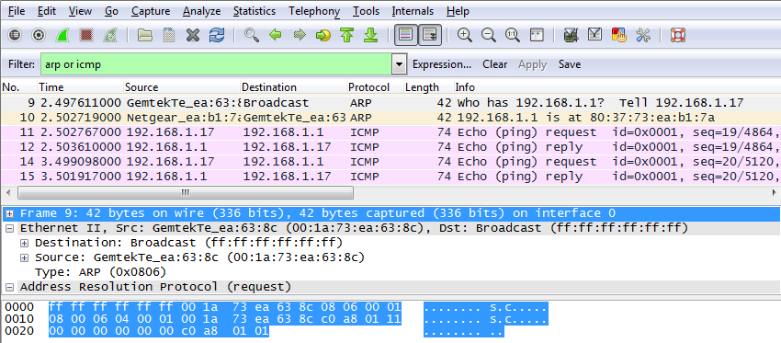

1. **Examine the Ethernet II header contents of an ARP request**

* The table below takes the first frame in the Wireshark capture and displays the data in the Ethernet II header fields

|  |  |  |
| --- | --- | --- |
| Field | Value | Description |
| Preamble | Not shown in capture | This field contains synchronizing bits, processed by the NIC hardware. |
| Destination Address | Broadcast (ff:ff:ff:ff:ff:ff) | Layer 2 addresses for frame. Each address is 48 bits long (6 octets), in 12 hexadecimal digits, 0-9,A-F. A common format is 12:34:56:78:9A:BC.  The first six hex numbers indicate NIC manufacturer, last six hex numbers are the serial number of the NIC.  Destination address may be broadcast (all ones) or a unicast. Source address is always unicast. |
| Source Address | GemtekTe_ea:63:8c  (00:1a:73:ea:63:8c) |
| Frame Type | 0x0806 | Type of upper-layer protocol in the data field. Many upper-layer protocols supported by Ethernet II. Two common frame types are:  Value Description  0x0800 IPv4 Protocol  0x0806 Address resolution protocol (ARP) |
| Data | ARP | Contains the encapsulated upper-level protocol. The data field is between 46 – 1,500 bytes. |
| FCS | Not shown in capture | Frame Check Sequence, used by NIC to identify errors during transmission. Value is computed by the sending machine, encompassing frame addresses, type, and data field. It is verified by the receiver. |

* Answer the questions below using this table & the Wireshark output:

|  |  |
| --- | --- |
| What is significant about the contents of the destination address field? |  |
| Why does the PC send out a broadcast ARP prior to sending the first ping request? |  |
| What is the MAC address of the source in the first frame? |  |
| What is the Vendor ID (OUI) of the Source’s NIC? |  |
| What portion of the MAC address is the OUI? |  |
| What is the Source’s NIC serial number? |  |
| What filter is used in Wireshark? |  |

**Part 2: Use Wireshark to Capture and Analyze Ethernet Frames**

* In Part 2, you will use Wireshark to capture local and remote Ethernet frames. You will then examine the information that is contained in the frame header fields.

1. **Determine the IP address of the default gateway on your PC**

* Use **ipconfig** to find your PC’s IP address & default gateway

|  |  |
| --- | --- |
| **PC IP Address** |  |
| **PC Default Gateway** |  |

1. **Start capturing traffic on your PC’s NIC**

* Open Wireshark, select correct interface (IT Carlow) & start capturing data
* If everything is working, you should be recording all lab transmissions
* Do not move onto step 3 unless everything is OK!

1. **Filter Wireshark to display only ICMP traffic**

* You can use the filter in Wireshark to block visibility of unwanted traffic
* The filter does not block the capture of unwanted data; it only filters what to display on the screen. For now, only ICMP traffic is to be displayed
* In the Wireshark **Filter** box, type **icmp**. The box should turn green if you typed the filter correctly. If the box is green, click **Apply** to apply the filter

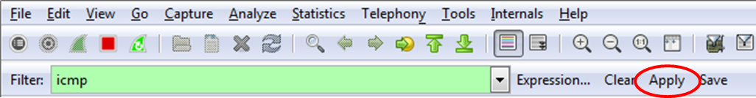

* May need to filter only your PC as well. E.g. icmp & ip.src == 149.153.x.y (your IP address)

1. **From the command prompt window, ping the default gateway of your PC**

* From the command window, ping the default gateway using the IP address that you recorded in Step 1.

1. **Stop capturing traffic on the NIC**

* Click the **Stop Capture** icon to stop capturing traffic.

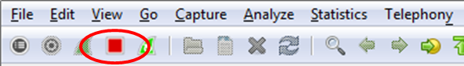

1. **Examine the first Echo (ping) request in Wireshark**

* The Wireshark main window is divided into three sections: the Packet List pane (top), the Packet Details pane (middle), and the Packet Bytes pane (bottom). If you selected the correct interface for packet capturing in Step 3, Wireshark should display the ICMP information in the Packet List pane of Wireshark, similar to the following example.

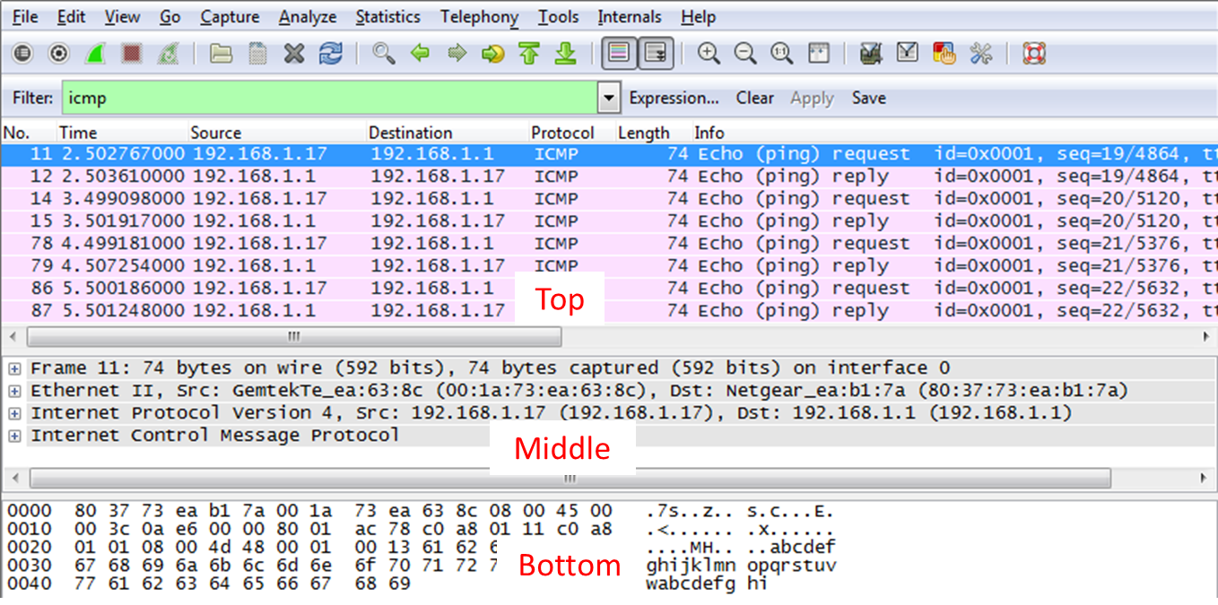

* In the Packet list pane click the first, then second frame listed. Should be highlighted in blue
* Answer the questions below using YOUR Wireshark output:

|  |  |
| --- | --- |
| What is the MAC address of your PC’s NIC? |  |
| What is the default gateway’s MAC address? |  |
| What type of frames are displayed? |  |
| What is the source IP address for the first frame? |  |
| What is the destination IP address for the first frame? |  |
| What is the source IP address for the second frame? |  |
| What is the destination IP address for the second frame? |  |
| Why are source/destination addresses swapped for first/second frames? |  |
| Click any ICMP line in middle section. Look at the data in the bottom pane. What do the last two digits spell? |  |

1. **Restart packet capture in Wireshark**

* Click the **Start Capture** icon to start a new Wireshark capture. You will receive a popup window asking if you would like to save the previous captured packets to a file before starting a new capture. Click **Continue without Saving**.

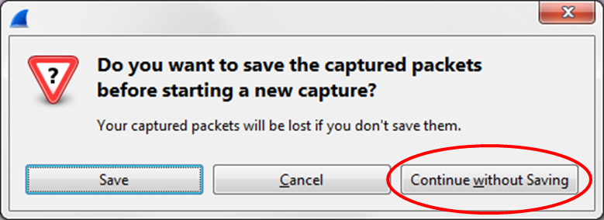

1. **Capture remote Ethernet Frames**

* From the command window, ping [www.cisco.com](http://www.cisco.com)
* Stop capturing packets
* Examine the new data in the packet list pane of Wireshark
* In the first echo (ping) request frame, what are the source and destination MAC addresses?

|  |  |
| --- | --- |
| **Source MAC address** |  |
| **Destination MAC address** |  |

* What are the source and destination IP addresses contained in the data field of the frame?

|  |  |
| --- | --- |
| **Source IP address** |  |
| **Destination IP address** |  |

* Compare these addresses to the addresses you received in Step 6
* The only address that changed is the destination IP address
* Why has the destination IP address changed, while the destination MAC address remained the same?
* Wireshark does not display the preamble field of a frame header. What does the preamble contain?
* Instructor Sign-off: ___________________________ Date: _______________

## Lab 5.2 View Network Device MAC Addresses

* Do in PT & physical devices
* Before attempting physical labs, sketch your configuration
* Complete separate answer boxes for both labs

1. Topology

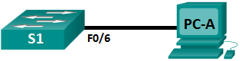

1. Addressing Table

|  |  |  |  |  |
| --- | --- | --- | --- | --- |
| Device | Interface | IP Address | Subnet Mask | Default Gateway |
| S1 | VLAN 1 | 192.168.1.1 | 255.255.255.0 | N/A |
| PC-A | NIC | 192.168.1.3 | 255.255.255.0 | 192.168.1.1 |

Background/Objectives:

* Every device on an Ethernet LAN is identified by a Layer 2 MAC address
* This address is assigned by the manufacturer and stored in the firmware of the NIC
* This lab will explore & analyze the components that make up a MAC address, and how you can find this information on a switch and a PC
* You will cable the lab, configure the switch and PC & verify your configurations by testing for network connectivity
* After the devices have been configured and network connectivity has been verified, you will use various commands to retrieve information from the devices to answer questions about your network equipment
* **Note**: Make sure that the switches have been erased and have no startup configurations. If you are unsure, ask your instructor.

Lab Tasks:

Part 1: Configure Devices and Verify Connectivity

1. **Cable network**
2. **Configure IPv4 Address for the PC**
3. **Configure basic settings for the switch**
4. **Verify Network Connectivity**

Part 2: Display, Describe, and Analyze Ethernet MAC Addresses

1. **Analyze the MAC address for the PC-A NIC**
2. **Analyze the MAC address for the S1 F0/6 interface**
3. **View the MAC addresses on the switch.**

Lab Work:

Part 1: Configure Devices and Verify Connectivity

* In this part, you will set up the network topology and configure basic settings

1. **Cable network**

* Attach the devices shown in the topology and cable as necessary
* Power on all the devices in the topology

1. **Configure IPv4 Address for the PC**

* Configure the IPv4 address, subnet mask, and default gateway address for PC-A
* From the command prompt on PC-A, ping the switch address (192.168.1.1)

|  |  |  |
| --- | --- | --- |
|  | **Packet Tracer** | **Physical Devices** |
| Were the pings successful? |  |  |
| Explain |  |  |

1. **Configure basic settings for the switch**

* In this step, you will configure the device name and the IP address, and disable DNS lookup on the switch:
* Console into the switch and enter global configuration mode.

Switch> **enable**

Switch# **configure terminal**

Enter configuration commands, one per line. End with CNTL/Z.

Switch(config)#

* Assign a hostname to the switch based on the Addressing Table.

Switch(config)# **hostname S1**

* Disable DNS lookup.

S1(config)# **no ip domain-lookup**

* Configure and enable the SVI interface for VLAN 1.

S1(config)# **interface vlan 1**

S1(config-if)# **ip address 192.168.1.1 255.255.255.0**

S1(config-if)# **no shutdown**

S1(config-if)# **end**

1. **Verify Network Connectivity**

* From the command prompt on PC-A, ping the switch address (192.168.1.1)

|  |  |  |
| --- | --- | --- |
|  | **Packet Tracer** | **Physical Devices** |
| Were the pings successful? |  |  |
| Explain |  |  |

Part 2: Display, Describe, and Analyze Ethernet MAC Addresses

* Every device on an Ethernet LAN has a MAC address that is assigned by the manufacturer and stored in the firmware of the NIC. Ethernet MAC addresses are 48-bits long. They are displayed using six sets of hexadecimal separated by dashes, colons, or periods. The following example shows the same MAC address using the three different notations:
* **00-05-9A-3C-78-00 00:05:9A:3C:78:00 0005.9A3C.7800**
* **Note**: MAC addresses are also called physical addresses, hardware addresses, or Ethernet hardware addresses
* You will issue commands to display the MAC addresses on a PC and a switch, and you will analyze the properties of each one

1. **Analyze the MAC address for the PC-A NIC**

* Before you analyze MAC address on PC-A, look at an example from a different PC NIC.
* Type **ipconfig /all** command to view the MAC address of your NIC
* An example screen output is shown below

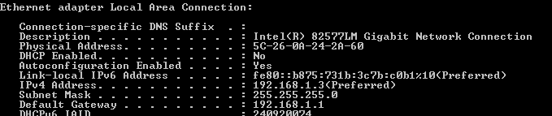

* Reading the MAC address from left to right, the first six hex digits refer to the vendor (manufacturer) of this device. These first six hex digits (3 bytes) are also known as the organizationally unique identifier (OUI). This 3-byte code is assigned to the vendor by the IEEE organization. To find the manufacturer, you can use a tool like [www.macvendorlookup.com](http://www.macvendorlookup.com) or go to the IEEE web site to find the registered OUI vendor codes. The IEEE web site address for OUI information is <http://standards.ieee.org/develop/regauth/oui/public.html>. The last six digits are the NIC serial number assigned by the manufacturer
* Using the output from the **ipconfig /all** command (above) answer the following questions:

|  |  |
| --- | --- |
| OUI portion of the MAC address for this device? |  |
| Serial number portion of the MAC address for this device? |  |
| Name of the vendor that manufactured this NIC |  |

* From command prompt on PC-A run the **ipconfig /all** command & answer the following:

|  |  |  |
| --- | --- | --- |
|  | **Packet Tracer** | **Physical Devices** |
| OUI portion of the MAC address for the NIC of PC-A? |  |  |
| Serial number portion of the MAC address for the NIC of PC-A |  |  |
| Name of the vendor that manufactured the NIC of PC-A |  |  |

1. **Analyze the MAC address for the S1 F0/6 interface**

* You can use a variety of commands to display MAC addresses on the switch
* E.g. **show interfaces** or **show arp**
* Console into S1 and use the **show interfaces vlan 1** command to find MAC address info
* A sample is shown below. Use output generated by your switch to answer the questions

S1# **show interfaces vlan 1**

Vlan1 is up, line protocol is up

Hardware is EtherSVI, address is 001b.0c6d.8f40 (bia 001b.0c6d.8f40)

Internet address is 192.168.1.1/24

MTU 1500 bytes, BW 1000000 Kbit/sec, DLY 10 usec,

reliability 255/255, txload 1/255, rxload 1/255

Encapsulation ARPA, loopback not set

<output omitted>

|  |  |  |
| --- | --- | --- |
|  | **Packet Tracer** | **Physical Devices** |
| What is the MAC address for VLAN 1 on S1? |  |  |
| What is the MAC serial number for VLAN 1? |  |  |
| What is the OUI for VLAN 1? |  |  |
| Based on this OUI what is the vendor name |  |  |
| What does **bia** stand for? |  | |
| Why does the output show the same MAC address twice? |  | |

* Another way to display the MAC address on the switch is to use the **show arp** command.
* Use the **show arp** command to display MAC address information. This command maps the Layer 2 address to its corresponding Layer 3 address. A sample is shown below. Use output generated by your switch to answer the questions

S1# **show arp**

Protocol Address Age (min) Hardware Addr Type Interface

Internet 192.168.1.1 - 001b.0c6d.8f40 ARPA Vlan1

Internet 192.168.1.3 0 5c26.0a24.2a60 ARPA Vlan1

|  |  |  |
| --- | --- | --- |
|  | **Packet Tracer** | **Physical Devices** |
| What Layer 2 addresses are displayed on S1? |  |  |
| **What Layer 3 addresses are displayed on S1?** |  |  |

1. **View the MAC addresses on the switch.**

* Issue the **show mac address-table** command on S1. A sample is shown below.
* Use output generated by your switch to answer the questions.

S1# **show mac address-table**

Mac Address Table

-------------------------------------------

Vlan Mac Address Type Ports

---- ----------- -------- -----

All 0100.0ccc.cccc STATIC CPU

All 0100.0ccc.cccd STATIC CPU

All 0180.c200.0000 STATIC CPU

All 0180.c200.0001 STATIC CPU

All 0180.c200.0002 STATIC CPU

All 0180.c200.000a STATIC CPU

All 0180.c200.000b STATIC CPU

All 0180.c200.000e STATIC CPU

All 0180.c200.000f STATIC CPU

All 0180.c200.0010 STATIC CPU

All ffff.ffff.ffff STATIC CPU

1 5c26.0a24.2a60 DYNAMIC Fa0/6

Total Mac Addresses for this criterion: 21

|  |  |  |
| --- | --- | --- |
|  | **PT** | **Physical** |
| Did switch display MAC address of PC-A? |  |  |
| If so, what was MAC address of PC-A? |  |  |
| What port was PC-A on? |  |  |
| Can you have broadcasts at the Layer 2 level? If so, what would the MAC address be? |  |  |
| Why would you need to know the MAC address of a device? |  | |

* Instructor Sign-off: ___________________________ Date: _______________

## Lab 5.3 Observe ARP with Windows CLI & IOS CLI

* Do in PT & physical devices
* Before attempting physical labs, sketch your configuration
* Complete separate answer boxes for both labs

1. Topology

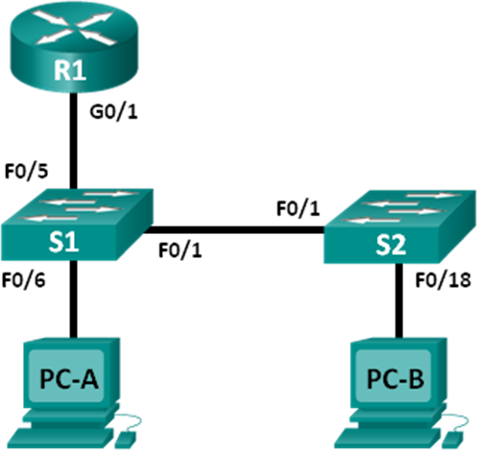

Addressing Table

|  |  |  |  |  |
| --- | --- | --- | --- | --- |
| Device | Interface | IP Address | Subnet Mask | Default Gateway |
| R1 | G0/1 | 192.168.1.1 | 255.255.255.0 | N/A |
| S1 | VLAN 1 | 192.168.1.11 | 255.255.255.0 | 192.168.1.1 |
| S2 | VLAN 1 | 192.168.1.12 | 255.255.255.0 | 192.168.1.1 |
| PC-A | NIC | 192.168.1.3 | 255.255.255.0 | 192.168.1.1 |
| PC-B | NIC | 192.168.1.2 | 255.255.255.0 | 192.168.1.1 |

1. Objectives/Background:

* The Address Resolution Protocol (ARP) is used by TCP/IP to map a Layer 3 IP address to a Layer 2 MAC address
* When a frame is placed on the network, it must have a destination MAC address. To dynamically discover the MAC address for the destination device, an ARP request is broadcast on the LAN. The device that contains the destination IP address responds & the MAC address is recorded in the ARP cache. Every device on the LAN keeps its own ARP cache (small area in RAM that holds ARP results). An ARP cache timer removes ARP entries that have not been used for a certain period of time.
* ARP is an excellent example of performance tradeoff. With no cache, ARP must continually request address translations each time a frame is placed on the network. This adds latency to the communication & could congest the LAN. Conversely, unlimited hold times could cause errors with devices that leave the network or change the Layer 3 address.
* ARP is a protocol that enables network devices to communicate with the TCP/IP protocol. Without ARP, there is no efficient method to build the datagram Layer 2 destination address. Also, ARP is a potential security risk. ARP spoofing (ARP poisoning), can be used by an attacker to inject the wrong MAC address association in a network. An attacker forges the MAC address of a device & frames are sent to the wrong destination. Manually configuring static ARP associations is one way to prevent ARP spoofing. Finally, an authorized MAC address list may be configured on Cisco devices to restrict network access to only approved devices.
* In this lab, you will use the ARP commands in both Windows and Cisco routers to display the ARP table. You will also clear the ARP cache and add static ARP entries.
* Note: Make sure that the routers and switches have been erased and have no startup configurations. If you are unsure, contact your instructor.

Lab Tasks:

**Part 1: Build and Configure the Network**

1. **Cable the network**
2. **Configure IP Addresses**
3. **Verify Connectivity**

Part 2: Use the Windows ARP Command

1. **Display ARP Cache**
2. **Adjust Entries in ARP Cache Manually**

Part 3: Use the IOS Show ARP Command

1. **Display ARP Entries on Router R1**
2. **Add ARP Entries on Router R1**
3. **Display ARP Entries on Switch S1**
4. **Add ARP Entries on Switch S1**

Lab Work:

**Part 1: Build and Configure the Network**

1. **Cable the network**

* Cable network using the topology above & label devices, disable DNS etc.
* Note: use Cisco 1941 routers & 2960 switches where possible & compensate
* If, for example you are using an 1841 router, there is no G0/1 interface
* Also, the use of **arp** in PT will be slightly different

1. **Configure IP Addresses**

* Configure PC, router & switch IP addresses, SNM, default gateways

1. **Verify Connectivity**

* Ping all devices from PC-B.
* Record results below
* Do not move on unless all pings are successful

|  |  |  |  |  |  |
| --- | --- | --- | --- | --- | --- |
| **From Device** | **Device** | **Interface** | **IP Address** | **Result (PT)** | **Result (Phys.)** |
| PC-B | PC-B | NIC | 192.168.1.2 |  |  |
| PC-B | PC-A | NIC | 192.168.1.3 |  |  |
| PC-B | S1 | VLAN1 | 192.168.1.11 |  |  |
| PC-B | S2 | VLAN1 | 192.168.1.12 |  |  |
| PC-B | R1 | G0/1 | 192.168.1.1 |  |  |

Part 2: Use the Windows ARP Command

1. **Display ARP Cache**

* The **arp** command allows the user to view and modify the ARP cache in Windows

1. Open a command window on PC-A and type **arp**:

* Note: arp use will be slightly different on PT than on physical devices

C:\Users\User1> **arp**

Displays and modifies the IP-to-Physical address translation tables used by

address resolution protocol (ARP).

ARP -s inet_addr eth_addr [if_addr]

ARP -d inet_addr [if_addr]

ARP -a [inet_addr] [-N if_addr] [-v]

-a Displays current ARP entries…

-d Deletes the host specified (may be wildcarded with * to delete all hosts)

-s Adds the host and associates the Internet address inet_addr

with the Physical address eth_addr.

eth_addr Specifies a physical address.

if_addr Specifies the Internet address of the interface whose address

Example:

> arp -s 157.55.85.212 00-aa-00-62-c6-09 .... Adds a static entry.

> arp -a .... Displays the arp table.

* Examine the output from **arp** on your PC (PC-A)

1. Complete the table below:

|  |  |  |
| --- | --- | --- |
|  | **PT** | **Physical** |
| What command would be used to display all entries in the ARP cache? |  |  |
| What command would be used to delete all ARP cache entries (flush ARP cache)? |  |  |
| What command would be used to delete the ARP cache entry for 192.168.1.11? |  |  |

1. Type **arp –a** to display the ARP table on (PC-A)

C:\Users\User1> **arp –a**

Interface: 192.168.1.3 --- 0xb

Internet Address Physical Address Type

192.168.1.1 d4-8c-b5-ce-a0-c1 dynamic

192.168.1.255 ff-ff-ff-ff-ff-ff static

224.0.0.22 01-00-5e-00-00-16 static

224.0.0.252 01-00-5e-00-00-fc static

239.255.255.250 01-00-5e-7f-ff-fa static

1. Ping from PC-A to PC-B to dynamically add entries in the ARP cache.

C:\Documents and Settings\User1> **ping 192.168.1.2**

C:\Users\User1> **arp –a**

Interface: 192.168.1.3 --- 0xb

Internet Address Physical Address Type

192.168.1.2 00-50-56-be-f6-db dynamic

|  |  |  |
| --- | --- | --- |
|  | **PT** | **Physical** |
| What is the physical address for the host with IP address of 192.168.1.2? |  |  |

1. **Adjust Entries in ARP Cache Manually**

* To delete entries in ARP cache, run **arp –d**. Addresses can be deleted individually by specifying the IP address, or all entries can be deleted with the wildcard
* Verify that the ARP cache contains the following entries: the R1 G0/1 default gateway (192.168.1.1), PC-B (192.168.1.2) and both switches (192.168.1.11 and 192.168.1.12).

1. From PC-A, ping all the addresses in the Address Table.
2. Verify that all the addresses have been added to the ARP cache. If the address is not in ARP cache, ping the destination address & verify address was added to ARP cache

* Should look like:

C:\Users\User1> **arp –a**

Interface: 192.168.1.3 --- 0xb

Internet Address Physical Address Type

192.168.1.1 d4-8c-b5-ce-a0-c1 dynamic

192.168.1.2 00-50-56-be-f6-db dynamic

192.168.1.11 0c-d9-96-e8-8a-40 dynamic

192.168.1.12 0c-d9-96-d2-40-40 dynamic

192.168.1.255 ff-ff-ff-ff-ff-ff static

224.0.0.22 01-00-5e-00-00-16 static

224.0.0.252 01-00-5e-00-00-fc static

239.255.255.250 01-00-5e-7f-ff-fa static

1. For the next step, you must open the command prompt as administrator

* **cmd** 🡪 **Run as administrator**. Click **Yes** to allow this program to make changes.

1. In the Administrator command prompt window, type **arp –d \***. This command deletes all the ARP cache entries. Verify all the ARP entries deleted by typing **arp –a**

* C:\windows\system32> **arp –d \***
* C:\windows\system32> **arp –a**

No ARP Entries Found.

1. Wait a few minutes. The Neighbor Discovery protocol starts to populate ARP cache again.

C:\Users\User1> **arp –a**

Interface: 192.168.1.3 --- 0xb

Internet Address Physical Address Type

192.168.1.255 ff-ff-ff-ff-ff-ff static

1. From PC-A, ping PC-B (192.168.1.2) and the switches (192.168.1.11 and 192.168.1.12) to add the ARP entries. Verify that the ARP entries have been added to the cache.

C:\Users\User1> **arp –a**

Interface: 192.168.1.3 --- 0xb

Internet Address Physical Address Type

192.168.1.2 00-50-56-be-f6-db dynamic

192.168.1.11 0c-d9-96-e8-8a-40 dynamic

192.168.1.12 0c-d9-96-d2-40-40 dynamic

192.168.1.255 ff-ff-ff-ff-ff-ff static

1. Record physical address for switch S2:

|  |  |  |
| --- | --- | --- |
|  | **PT** | **Physical** |
| What is the physical address switch S2? |  |  |

1. Delete a specific ARP cache entry by typing **arp –d *inet-addr***. At the command prompt, type **arp -d 192.168.1.12** to delete the ARP entry for S2
2. Type **arp –a** to verify that the ARP entry for S2 has been removed from the ARP cache.

C:\windows\system32> **arp –d 192.168.1.12**

C:\Users\User1> **arp –a**

Interface: 192.168.1.3 --- 0xb

Internet Address Physical Address Type

192.168.1.2 00-50-56-be-f6-db dynamic

192.168.1.11 0c-d9-96-e8-8a-40 dynamic

192.168.1.255 ff-ff-ff-ff-ff-ff static

1. You can add a specific ARP cache entry by typing **arp –s.** The IP address and MAC address for S2 will be used in this example. Use the MAC address for S2 recorded above
2. Verify that the ARP entry for S2 has been added to the cache.

* C:\windows\system32> **arp –s 192.168.1.12 0c-d9-96-d2-40-40**
* C:\windows\system32> **arp –a**

Part 3: Use the IOS Show ARP Command

* The Cisco IOS can also display the ARP cache on routers and switches with the **show arp** or **show ip arp** command.

1. **Display ARP Entries on Router R1**

R1# **show arp**

Protocol Address Age (min) Hardware Addr Type Interface

Internet 192.168.1.1 - d48c.b5ce.a0c1 ARPA GigabitEthernet0/1

Internet 192.168.1.2 0 0050.56be.f6db ARPA GigabitEthernet0/1

Internet 192.168.1.3 0 0050.56be.768c ARPA GigabitEthernet0/1

R1#

* Notice there is no Age (-) for the first entry, router interface G0/1 (LAN default gateway). Age is the number of minutes that the entry has been in ARP cache and is incremented for the other entries. Neighbor Discovery protocol populates PC-A & PC-B IP & MAC address ARP entries.

1. **Add ARP Entries on Router R1**

* You can add ARP entries to the ARP table of the router by pinging other devices:

1. Ping switch S1
2. Verify that an ARP entry for switch S1 has been added to the ARP table of R1

R1# **ping 192.168.1.11**

Type escape sequence to abort.

Sending 5, 100-byte ICMP Echos to 192.168.1.11, timeout is 2 seconds:.!!!!

Success rate is 80 percent (4/5), round-trip min/avg/max = 1/2/4 ms

R1# **show ip arp**

Protocol Address Age (min) Hardware Addr Type Interface

Internet 192.168.1.1 - d48c.b5ce.a0c1 ARPA GigabitEthernet0/1

Internet 192.168.1.2 6 0050.56be.f6db ARPA GigabitEthernet0/1

Internet 192.168.1.3 6 0050.56be.768c ARPA GigabitEthernet0/1

Internet 192.168.1.11 0 0cd9.96e8.8a40 ARPA GigabitEthernet0/1

R1#

1. **Display ARP Entries on Switch S1**

S1# **show ip arp**

Protocol Address Age (min) Hardware Addr Type Interface

Internet 192.168.1.1 46 d48c.b5ce.a0c1 ARPA Vlan1

Internet 192.168.1.2 8 0050.56be.f6db ARPA Vlan1

Internet 192.168.1.3 8 0050.56be.768c ARPA Vlan1

Internet 192.168.1.11 - 0cd9.96e8.8a40 ARPA Vlan1

S1#

1. **Add ARP Entries on Switch S1**

* By pinging other devices, ARP entries can also be added to the ARP table of the switch.

1. From switch S1, ping switch S2
2. Verify that the ARP entry for switch S2 has been added to ARP table of S1.

S1# **ping 192.168.1.12**

Type escape sequence to abort.

Sending 5, 100-byte ICMP Echos to 192.168.1.12, timeout is 2 seconds:.!!!!

Success rate is 80 percent (4/5), round-trip min/avg/max = 1/2/8 ms

S1# **show ip arp**

Protocol Address Age (min) Hardware Addr Type Interface

Internet 192.168.1.1 5 d48c.b5ce.a0c1 ARPA Vlan1

Internet 192.168.1.2 11 0050.56be.f6db ARPA Vlan1

Internet 192.168.1.3 11 0050.56be.768c ARPA Vlan1

Internet 192.168.1.11 - 0cd9.96e8.8a40 ARPA Vlan1

Internet 192.168.1.12 2 0cd9.96d2.4040 ARPA Vlan1

S1#

* Instructor Sign-off: ___________________________ Date: _______________

## Lab 5.4 Examine Switch MAC Address Table

* Do in PT & physical devices
* Before attempting physical labs, sketch your configuration
* Complete separate answer boxes for both labs
* Same topology as previous lab!!

1. Topology

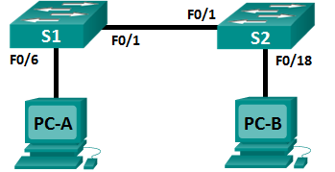

Addressing Table

|  |  |  |  |  |
| --- | --- | --- | --- | --- |
| Device | Interface | IP Address | Subnet Mask | Default Gateway |
| S1 | VLAN 1 | 192.168.1.11 | 255.255.255.0 | 192.168.1.1 |
| S2 | VLAN 1 | 192.168.1.12 | 255.255.255.0 | 192.168.1.1 |
| PC-A | NIC | 192.168.1.3 | 255.255.255.0 | 192.168.1.1 |
| PC-B | NIC | 192.168.1.2 | 255.255.255.0 | 192.168.1.1 |

Lab Tasks:

**Part 1: Build & Configure the Network**

1. **Cable the network**
2. **Configure IP Addresses**
3. **Verify Connectivity**

**Part 2: Examine the Switch MAC Address Table**

1. **Record network device MAC addresses**
2. **Display switch MAC address table**
3. **Clear S2 MAC address table & display MAC address table again**
4. **From PC-B, ping network devices & observe switch MAC address table**

Objectives:

* The purpose of a Layer 2 LAN switch is to deliver Ethernet frames to host devices on the local network. The switch records host MAC addresses that are visible on the network & maps those MAC addresses to its own Ethernet switch ports. This process is called building the MAC address table. When a switch receives a frame from a PC, it examines the frame’s source and destination MAC addresses. The source MAC address is recorded and mapped to the switch port from which it arrived. Then the destination MAC address is looked up in the MAC address table. If the destination MAC address is a known address, then the frame is forwarded out of the corresponding switch port associated with that MAC address. If the MAC address is unknown, then the frame is broadcasted out of all switch ports, except the one from which it came. It is important to observe and understand the function of a switch and how it delivers data on the network.
* Switches are used to interconnect and deliver information to computers on LANs. Switches deliver Ethernet frames to host devices identified by NIC MAC addresses.
* In Part 1, you will build a multi-switch topology with a trunk linking the two switches. In Part 2, you will ping various devices and observe how the two switches build their MAC address tables.
* **Note**: The switches used are Cisco Catalyst 2960. Other switches can be used. Depending on the model and Cisco IOS version, the commands available and output produced might vary from what is shown in the labs.
* **Note**: Make sure that the switches have been erased and have no startup configurations. If you are unsure contact your instructor.

Lab Work:

**Part 1: Build & Configure the Network**

* Cable network & config network devices (same as Lab 5.3)

1. **Cable the network**

* Cable network using the topology above & label devices, disable DNS etc.
* Note: use Cisco 1941 routers & 2960 switches where possible & compensate
* If, for example you are using an 1841 router, there is no G0/1 interface
* Also, the use of **arp** in PT will be slightly different

1. **Configure IP Addresses**

* Configure PC, router & switch IP addresses, SNM, default gateways

1. **Verify Connectivity**

* Ping all devices from PC-B.
* Record results below
* Do not move on unless all pings are successful!!

|  |  |  |  |  |  |
| --- | --- | --- | --- | --- | --- |
| **From Device** | **To Device** | **Interface** | **IP Address** | **Result (PT)** | **Result (Phys.)** |
| PC-B | PC-B | NIC | 192.168.1.2 |  |  |
| PC-B | PC-A | NIC | 192.168.1.3 |  |  |
| PC-B | S1 | VLAN1 | 192.168.1.11 |  |  |
| PC-B | S2 | VLAN1 | 192.168.1.12 |  |  |

* Note: first pings may fail.

**Part 2: Examine the Switch MAC Address Table**

* Use **show** commands to observe process of building switch MAC address table
* Switch learns MAC addresses & builds MAC address table as devices initiate communications on the network

1. **Record network device MAC addresses**

PC-A> **ipconfig /all**

PC-B> **ipconfig /all**

S1# **show interface f0/1**

S2# **show interface f0/1**

|  |  |  |
| --- | --- | --- |
|  | **PT** | **Physical** |
| PC-A MAC Address |  |  |
| PC-B MAC Address |  |  |
|  | **PT** | **Physical** |
| S1 Fa0/1 MAC Address |  |  |
| S2 Fa0/1 MAC Address |  |  |

1. **Display switch MAC address table**:

* Record any MAC addresses displayed, plus the ports the are mapped to
* Ignore MAC addresses mapped to the CPU

S2# **show mac address-table**

|  |  |  |  |
| --- | --- | --- | --- |
| **Vlan** | **Mac address** | **Type** | **Ports** |
|  |  | DYNAMIC |  |
|  |  | DYNAMIC |  |

1. **Clear S2 MAC address table & display MAC address table again**

* Clear MAC address table & quickly display the table again

S2# **clear mac address-table dynamic**

S2# **show mac address-table**

|  |  |  |  |
| --- | --- | --- | --- |
| **Vlan** | **Mac address** | **Type** | **Ports** |
| 1 |  | DYNAMIC |  |

* Wait 10 seconds & display the table again
* S2# **show mac address-table**
* Has output changed?

1. **From PC-B, ping network devices & observe switch MAC address table**
2. From PC-B, type **arp –a**
3. From PC-B, PC-A, S1 & S2. All should be successful:

PC-B> **arp -a**

|  |  |  |
| --- | --- | --- |
| **Internet Address** | **Physical Address** | **Type** |
|  |  |  |
|  |  |  |
|  |  |  |

PC-B> **ping PC-A**

PC-B> **ping S1**

PC-B> **ping S2**

1. From S2, enter show mac address-table. Should be populated with 4 MAC addresses:

S2# **show mac address-table**

|  |  |  |  |
| --- | --- | --- | --- |
| **Vlan** | **Mac address** | **Type** | **Ports** |
| 1 |  | DYNAMIC |  |
| 1 |  | DYNAMIC |  |
| 1 |  | DYNAMIC |  |
| 1 |  | DYNAMIC |  |

Reflection:

* When you ping a device, arp table is populated!
* See the similarities between output of **arp** & **show mac address-table**
* On Ethernet networks, data is delivered to devices by their MAC addresses. For this to happen, switches and PCs dynamically build ARP caches and MAC address tables. With only a few computers on the network this process seems fairly easy. What might be some of the challenges on larger networks?
* Instructor Sign-off: ___________________________ Date: _______________

# Chapter 6: Network Layer

## Lab 6.1 Exploring Router Physical Characteristics

* Use physical devices

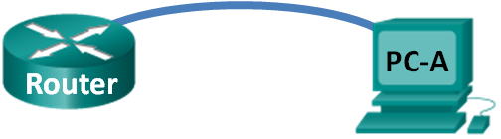

1. Objectives/Background:

* In this lab, you will examine the outside of the router to become familiar with its characteristics and components (power switch, management ports, LAN/WAN interfaces, indicator lights, module expansion slots, memory expansion slots, and USB ports)
* You will also identify the internal components and characteristics of the IOS by consoling into the router and issuing various commands, such as **show version** and **show interfaces**, from the CLI
* Work in groups
* **Note**: Cisco 19451 ISR router used in this lab
* Make sure that the router has been erased and have no startup configurations. If you are unsure contact your instructor.

Lab Tasks:

**Part 1: Examine Router External Characteristics**

1. **Identify power switch**
2. **Identify management ports**
3. **Identify LAN & WAN interfaces**
4. **Identify module expansion & memory slots**
5. **Identify USB ports**
6. **Complete table (ports/slots)**
7. **Examine front panel indicator lights**
8. **Examine backplane indicator lights**
9. **Complete table (indicator lights)**

**Part 2: Examine Router Internal Characteristics**

1. **Establish console connection to router**
2. **Run “show version” command**
3. **Run “show interface” command**

**Part 1: Examine Router External Characteristics**

* Identify parts of Cisco router (management ports, LAN & WAN interfaces, etc.)
* Use Cisco 1941

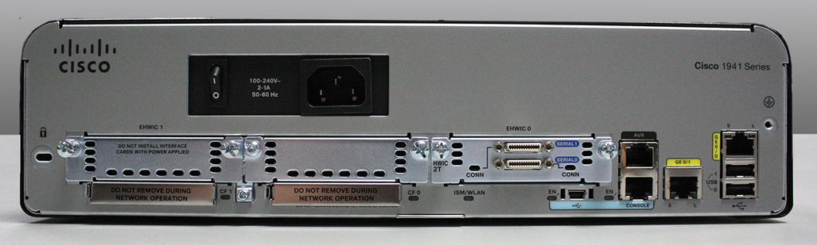

1. **Identify power switch**

* Circle & label the power switch.

1. **Identify management ports**

* Circle & label the management ports
* How many management ports are there? What are they used for?
* (Ignore USB ports in this step)
* (Write answers in the table in step 6 below)

1. **Identify LAN & WAN interfaces**

* Circle & label the LAN interfaces
* Circle & label the WAN interfaces
* How many LAN interfaces are there? What are they used for?
* How many WAN interfaces are there? What are they used for?
* (Write answers in the table in step 6 below)

1. **Identify module expansion & memory slots**

* The Cisco 1941 ISR is a modular platform and comes with module expansion slots for varied network connectivity requirements & CompactFlash memory slots for high-speed storage.
* Circle & label the module expansion slots. How many module slots are there? What type of module expansion slots are they?
* Circle and label the CompactFlash memory slots. How many memory slots are there?
* (Write answers in the table in step 6 below)

1. **Identify USB ports**

* Circle & label the USB ports
* Circle & label the mini-USB ports
* What are they used for?
* (Write answers in the table in step 6 below)

1. **Complete table (ports/slots)**

|  |  |  |
| --- | --- | --- |
|  | **Number of Ports/Slots** | **What is it used for?** |
| **Management Ports** |  |  |
| **LAN Interfaces** |  |  |
| **WAN Interfaces** |  |  |
| **Module Expansion Slots** |  |  |
| **Memory Slots** |  |  |
| **USB 2.0 Ports** |  |  |
| **Mini-USB Ports** |  |  |

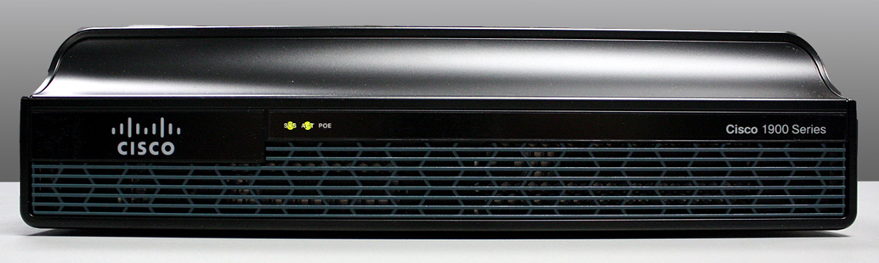

1. **Examine front panel indicator lights**

* Examine indicator lights on front panel of router
* Lights are labelled SYS, ACT & POE
* What do the labels mean?
* (Write answers in the table in step 9 below)

1. **Examine backplane indicator lights**

* Examine indicator lights on backplane of router
* There are three visible activity lights, one for each of the connected interfaces and management ports. Examine the interface lights on your router
* Lights are labelled Serial, Ethernet, Console, etc
* What do the labels mean?
* Aside from the management ports and network interfaces, what other indicator lights are on the backplane of the router and what might their purpose be?
* (Write answers in the table in step 9 below)

1. **Complete table (indicator lights)**

|  |  |  |
| --- | --- | --- |
| **Front-Panel Lights** | **Meaning** | **Notes** |
| **SYS** |  |  |
| **ACT** |  |  |
| **POE** |  |  |
| **Backplane Lights** | **Meaning** | **Notes** |
| **Serial** |  |  |
| **FastEthernet** |  |  |
| **Console** |  |  |
| **Other** |  |  |

**Part 2: Examine Router Internal Characteristics**

* Use **show** commands to observe information about Cisco router
* Use PT?

1. **Establish console connection to router**
2. **Run “show version” command**

* Router# **show version**
* Complete the table below

|  |  |
| --- | --- |
| **Cisco IOS version** |  |
| **System image filename** |  |
| **Bootstrap program version** |  |
| **Router uptime** |  |
| **Amount of DRAM** |  |
| **Network interfaces** |  |
| **Amount of compact flash** |  |
| **Amount of Flash Memory** |  |
| **Amount of NVRAM** |  |
| **Configuration register setting** |  |

1. **Run “show interface” command**

* Router# **show interface gigabitEthernet 0/0**
* Router# **show interface serial 0/0/0**
* (Use shortcuts if possible: e.g. show int g0/0)

|  |  |
| --- | --- |
| **g0/0 hardware type** |  |
| **g0/0 MAC Address** |  |
| **g0/0 administratively up or down?** |  |
| **g0/0 line protocol up or down?** |  |
|  |  |
| **s0/0/0 hardware type** |  |
| **s0/0/0 administratively up or down?** |  |
| **s0/0/0 line protocol up or down?** |  |
| **s0/0/0 frame encapsulation type** |  |

**Reflection:**

|  |  |
| --- | --- |
| **Purpose of EHWIC expansion slot** |  |
| **Why would you need to upgrade flash?** |  |
| **Purpose of USB min-port** |  |

* Try this in on equivalent PT device if time available
* Instructor Sign-off: ___________________________ Date: _______________

## Lab 6.2 View Host Routing Tables

* **N.B. Use IT Carlow Network (not Packet Tracer)**

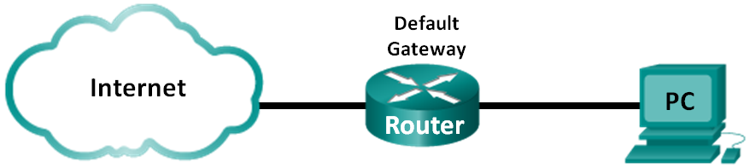

* A PC host finds the route to a destination using its routing table
* The host routing table is like a router routing table but specific to a host
* Both host routing table & router routing table needed for packet to reach its final destination

**Lab Tasks:**

**Part 1: Access the Host Routing Table**

1. **Record PC Info**
2. **Display Routing Tables**:
3. **Examine Interface List**

**Part 2: Examine IPv4 Host Routing Table Entries**

1. **Display Routing Tables**

**Lab Work:**

**Part 1: Access the Host Routing Table**

1. **Record PC Info**

* On command window, type **ipconfig/all** & complete table below
* Ignore the VMware stuff etc. (just focus on itcarlow.ie network):

|  |  |
| --- | --- |
| **IPv4 Address** |  |
| **MAC Address** |  |
| **Default Gateway** |  |

1. **Display Routing Tables**:

* On command window, type **netstat –r** (or **route print**) to display host routing table
* List the three sections in the output. The first is done for you:

|  |  |
| --- | --- |
| **1** | **Interface List** |
| **2** |  |
| **3** |  |

1. **Examine Interface List**

* The first section (Interface List) displays MAC addresses & assigned interface number of every network-capable interface on the host. There are 3 columns.
* Complete the table below for your IT Carlow Ethernet interface

|  |  |  |
| --- | --- | --- |
| **Column** | **Contents** | **Your Ethernet Interface** |
| **1** | Interface Number |  |
| **2** | MAC addresses associated with interface |  |
| **3** | Interface manufacturer & description |  |

**Part 2: Examine IPv4 Host Routing Table Entries**

1. **Display Routing Tables**

* The second section of **netstat –r** shows all known IPv4 routes
* The output is divided into 5 columns
* Complete the table below for your IT Carlow Ethernet interface (first row of **netstat** output only)

|  |  |  |  |
| --- | --- | --- | --- |
| **Column** | **Contents** | **Description** | **Your Ethernet Interface** |
| **1** | Network Destination | Reachable network |  |
| **2** | Netmask | Subnet mask |  |
| **3** | Gateway | Default gateway IP |  |
| **4** | Interface | Your IP address |  |
| **5** | Metric | Route cost |  |

1. **Determine Local & Remote Host Route**

* Based on the contents of the IPv4 routing table, if the PC wanted to send a packet to 149.153.105.15, where would it send the packet?
* If the PC wanted to send a packet to a remote host located at 172.217.23.3, where would it send the packet?

|  |  |  |
| --- | --- | --- |
| **Destination** | **IP Address** | **Where to send packet** |
| Local | 149.153.105.15 |  |
| Remote | 172.217.23.3 |  |

* Instructor Sign-off: ___________________________ Date: _______________

## Lab 6.3 Create Network Topology Network Using Routing Table

**Lab Tasks:**

* Given the output generated by a router’s show ip route command, use Packet Tracer to build a topology model using this routing information.
* Use PT only

**Lab Work:**

* The following should be used in your topology model:
* 1 Catalyst 2960 switch
* 1 Cisco Series 1941 Router with one HWIC-4ESW switching port modular card
* 3 PCs (can be servers, generic PCs, laptops, etc.)
* Work in pairs
* Use the note tool in Packet Tracer to indicate the addresses of the router interfaces and possible addresses for the end devices you chose for your model.
* Label all end devices, ports, and addresses ascertained from the show ip route output/routing table information in your Packet Tracer file.
* Reading a routing table can verify how a network has been addressed logically.
* A routing table can assist with identifying the physical topology of the network.
* A routing table identifies to the reader which ports are operating and on which networks they are operating

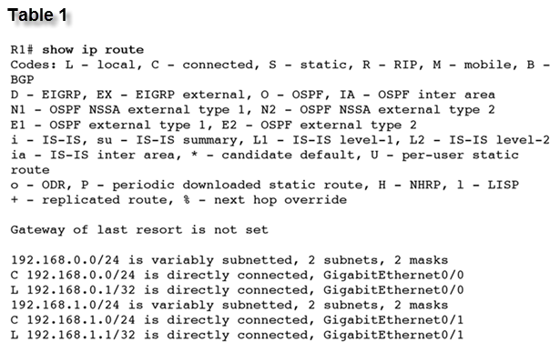

1. 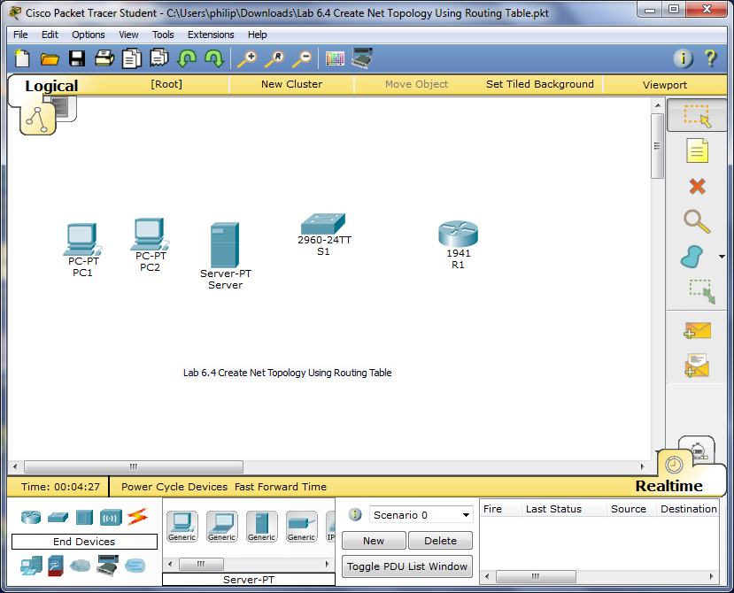
2. Reflection

What was the hardest part of designing this network model? Explain your answer.

* Instructor Sign-off: ___________________________ Date: _______________

## Lab 6.4 Build a Router & Switch Network

* Do in PT & physical devices (PT first!)
* Before attempting physical labs, sketch your configuration
* Work in groups for physical lab!

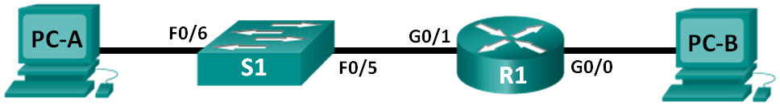

1. Topology

|  |  |  |  |  |  |
| --- | --- | --- | --- | --- | --- |
| Device | Interface (1941) | Interface (1841) | IP Address | Subnet Mask | Default Gateway |
| R1 | G0/0 | Fa0/0 | 192.168.0.1 | 255.255.255.0 | N/A |
| G0/1 | Fa0/1 | 192.168.1.1 | 255.255.255.0 | N/A |
| PC-A | NIC | NIC | 192.168.1.3 | 255.255.255.0 | 192.168.1.1 |
| PC-B | NIC | NIC | 192.168.0.3 | 255.255.255.0 | 192.168.0.1 |

1. Passwords

|  |  |  |
| --- | --- | --- |
| Device | Security Type | Password |
| R1 | Console | **cisco** |
| R1 | Privileged Exec | **class** |
| R1 | Telnet (vty) | **class** |

1. Objectives:

* In this lab, you will cable the equipment as shown in the topology diagram. You will then configure the devices to match the addressing table. Next, you will verify your configurations by testing for network connectivity.
* Finally, you will use IOS commands to retrieve information from the devices to answer questions about your network equipment.
* **Note**: Ensure that the routers & switches have been erased and have no startup configurations. Consult with your instructor for procedure to initialize & reload a device

1. Required Resources

* 1 Router (Cisco 1941). If using 1841, use Fa0 interfaces & crossover cable to PC-B
* 1 Switch (Cisco 2960), 2 PCs
* Console cables to configure the Cisco IOS devices via the console ports
* Ethernet cables as shown in the topology
* **Note**: The Gigabit Ethernet interfaces on Cisco 1941 routers are autosensing and an Ethernet straight-through cable may be used between the router and PC-B. If using another model Cisco router, it may be necessary to use an Ethernet crossover cable.
* Note: autosensing feature may NOT work in Packet Tracer!!

**Lab Tasks:**

Part 1: Set Up the Topology and Initialize Devices

1. **Cable network as shown in topology**
2. **Initialize & reload router & switch**

Part 2: Configure Devices and Verify Connectivity

1. **Assign static IP information to the PC interfaces**
2. **Configure the Router**

Part 3: Display Device Information

1. **Retrieve hardware and software information from the network devices**
2. **Display routing table on the router**
3. **Display interface information on the router**
4. **Display a summary list of the interfaces on the router and switch**

**Lab Work:**

Part 1: Set Up the Topology and Initialize Devices

1. **Cable network as shown in topology**:

* Attach the devices shown in the topology diagram
* [Note: need to add HWIC-2T module to router (right-hand-side) in PT]
* Power on all the devices in the topology.

1. **Initialize & reload router & switch**:

* If config files previously saved on the router or switch, initialize and reload these devices back to their basic configurations.

Part 2: Configure Devices and Verify Connectivity

1. **Assign static IP information to the PC interfaces**:

* Configure the IP address, subnet mask, and default gateway settings on PC-A
* Configure the IP address, subnet mask, and default gateway settings on PC-B
* Ping PC-B from a command prompt window on PC-A.
* Why were the pings not successful?

1. **Configure the Router**

* Console into the router and enable privileged EXEC mode
* Enter configuration mode
* Assign a device name to the router
* Disable DNS lookup to prevent the router from attempting to translate incorrectly entered commands as though they were host names
* Assign passwords (see table) & enable login
* Encrypt the clear text passwords
* Create a banner that warns anyone accessing device that unauthorized access is prohibited
* Configure and activate both interfaces on the router
* Configure an interface description for each interface indicating which device is connected to it
* Save running configuration to the startup configuration file
* Set the clock on the router
* Ping PC-B from a command prompt window on PC-A
* Were the pings successful? _____________________________________________
* Why? _____________________________________________
* Instructor Sign-off: ___________________________ Date: _______________

Part 3: Display Device Information

1. **Retrieve hardware and software information from the network devices**:

* Use the **show version** command to answer the following questions about the router:

|  |  |
| --- | --- |
| **Name of IOS image router is running** |  |
| **Amount of DRAM router has** |  |
| **Amount of NVRAM router has** |  |
| **Amount of Flash memory router has** |  |

* Use the **show version** (& **show flash**) command to answer the following about the switch:

|  |  |
| --- | --- |
| **Name of IOS image switch is running** |  |
| **Amount of DRAM switch has** |  |
| **Amount of NVRAM switch has** |  |
| **Model number of switch** |  |

1. **Display routing table on the router**:

* Use the **show ip route** command on the router to complete the table below:

|  |  |
| --- | --- |
| **Code used in routing table to indicate directly connected subnet** |  |
| **Code used in routing table to indicate directly connected interface** |  |
| **Number of route entries coded with a C code in routing table** |  |
| **Interface types associated to the C coded routes** |  |

1. **Display interface information on the router**:

* Use the **show interface g0/1** command on the router to complete the table below:

|  |  |
| --- | --- |
| **Operational status of the G0/1 interface** |  |
| **MAC address of the G0/1 interface** |  |
| **Internet address displayed by this command** |  |

1. **Display a summary list of the interfaces on the router and switch**:

* There are several commands that can be used to verify an interface configuration. One of the most useful of these is the **show ip interface brief** command. The command output displays a summary list of the interfaces on the device
* Use the **show ip interface brief** command on the router to complete the table below:

R1# **show ip interface brief**

|  |  |  |  |  |  |
| --- | --- | --- | --- | --- | --- |
| **Interface** | **IP Address** | **OK?** | **Method** | **Status** | **Protocol** |
| **GigabitEthernet 0/0** |  |  |  |  |  |
| **GigabitEthernet 0/1** |  |  |  |  |  |
| **Serial 0/0/0** |  |  |  |  |  |
| **Serial 0/0/1** |  |  |  |  |  |

* Should resemble:

Interface IP-Address OK? Method Status Protocol

Embedded-Service-Engine0/0 unassigned YES unset administratively down down

GigabitEthernet0/0 192.168.0.1 YES manual up up

GigabitEthernet0/1 192.168.1.1 YES manual up up

Serial0/0/0 unassigned YES unset administratively down down

Serial0/0/1 unassigned YES unset administratively down down

R1#

* Use the **show ip interface brief** command on the switch to complete the table below:

S1# **show ip interface brief**

|  |  |  |  |  |  |
| --- | --- | --- | --- | --- | --- |
| **Interface** | **IP Address** | **OK?** | **Method** | **Status** | **Protocol** |
| **Vlan1** |  |  |  |  |  |
| **Fa0/5** |  |  |  |  |  |
| **Fa0/6** |  |  |  |  |  |

* Should resemble:

Interface IP-Address OK? Method Status Protocol

Vlan1 unassigned YES manual up up

FastEthernet0/5 unassigned YES unset up up

FastEthernet0/6 unassigned YES unset up up

1. Reflection

* If the G0/1 interface showed administratively down, what interface configuration command would you use to turn the interface up?
* What would happen if you had incorrectly configured interface G0/1 on the router with an IP address of 192.168.1.2?
* Instructor Sign-off: ___________________________ Date: _______________

# Appendices:

## Appendix A: Network Device Symbols

* Note: only basic devices shown

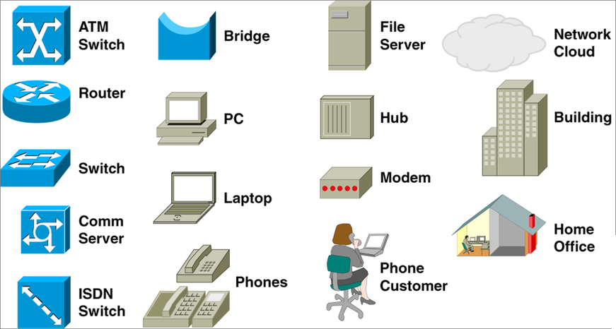

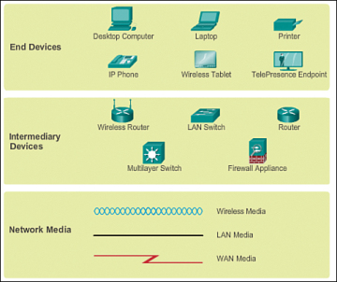

## Appendix B: Useful IOS Commands (CFY Net CA1 Lab Exam)

Switch > **enable**

Switch # **config t**

Switch (config)# **enable pasword** *password*

Switch (config)# **enable secret** *password*

Switch (config)# **hostname** *name*

Switch (config)# **banner motd #***Message*

Switch (config)# **no ip domain-lookup**

Switch(config)# **line console 0**

Switch(config-line)# **password** *password*

Switch(config-line)# **login**

Switch(config)# **line vty 0 15**

Switch(config-line)# **password** *password*

Switch(config-line)# **login**

Switch (config)# **interface vlan** *vlan-number*

Switch (config-if)# **description** *Interface Description*

Switch (config-if)# **ip address** *ip-add SNM*

Switch (config-if)# **no shutdown**

Switch (config)# **service password-encryption**

Switch# **show running-config**

Switch# **show startup-config**

Switch# **show ip int brief**

Switch# **show version**

Switch # **copy run start**

* Note: use CTRL+SHIFT+6 to cancel domain lookup

## Appendix C: Useful IOS Commands (CFY Net CA2 Lab Exam)

* Note: some commands apply to both routers & switches

Router > **enable**

Router # **config t**

Router (config)# **enable password** *password*

Router (config)# **enable secret** *password*

Router (config)# **hostname** *name*

Router (config)# **banner motd #***Message*

Router (config)# **no ip domain-lookup**

Router (config)# **line console 0**

Router (config-line)# **password** *password*

Router (config-line)# **login**

Router (config)# **line vty 0 15** (*or* **0 4** *and* **5 15**)

Router (config-line)# **password** *password*

Router (config-line)# **login**

Router (config)# **service password-encryption**

Router (config)# **interface** *interface*

Router (config-if)# **ip address** *ip-add SNM*

Router (config-if)# **description** *interface description*

Router (config-if)# **no shutdown**

Router# **show running-config**

Router# **show startup-config**

Router# **show ip int brief**

Router# **show ip route**

Router # **copy run start**

Router # **erase startup-config**

Router # **reload**

Switch (config)# **interface vlan** *vlan-number*

Switch (config-if)# **ip address** *ip-add SNM*

Switch (config-if)# **description** *interface description*

Switch (config-if)# **no shutdown**

Switch (config)# **service password-encryption**

Switch (config)# **ip default-gateway** *ip-add*

Switch # **clock set** *time & date*

* Note: use CTRL+SHIFT+6 to cancel domain lookup

## Appendix D: Physical Device Cabling

1. **Colour Coding**

* Each bench in Lab303 is clearly labelled with a code: 1A, 1B, 2C, 2D, 3E, 3F
* Each bench in Lab303 has 4 Ethernet sockets for each PC
* Usually 3 are in use: Grey (ITCARLOW NIC), Blue (Console), Red (CCNA NIC)
* Blue & Red connect to corresponding sockets in the CCNA wiring rack
* Grey connects to College LAN (ignore)



Cables left to right:

Grey, Blue, Red





1. **Console Connection**

* Connect to switch/router console port (blue cable)

1. On your bench, find the socket number for your console connection (2C14 in diagram)
2. On the patch panel, find the same socket number
3. Choose a switch/router (bottom switch in diagram)
4. Connect a blue Cat5 cable from socket in step b to console port of switch/router
5. Test your connection (use Terminal on PC)
6. **PC Connection**

* Connect to switch/router Ethernet port (red cable)

1. On your bench, find the socket number for your CCNA NIC connection (2C15 in diagram)
2. On the patch panel, find the same socket number
3. Choose a switch/router
4. Connect a red Cat5 cable from socket in step b to Ethernet port of switch/router
5. Test your connection (use Terminal command line window on PC)
6. **Connect switches together**

* Connect red Cat5 cable between switches
* Should see green lights
* **Note: if you are using 2950 switches, or connecting 2950 to 2960, you will need a crossover cable**



1. **Cabling Examples**

* The diagram below shows a simple use of horizontal & patch cables

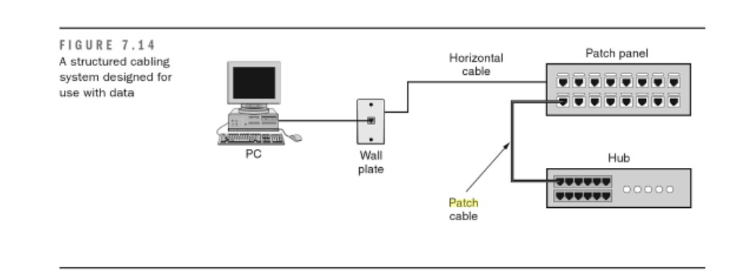

* **Lab 2.2 (PC-A = 2C14)**

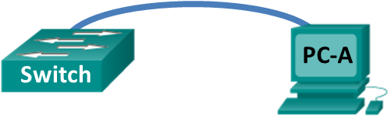

|  |  |  |
| --- | --- | --- |
|  |  | Switch Back |
| C |

|  |  |  |  |  |  |  |  |  |  |  |  |  |  |  |  |  |  |  |  |  |  |  |  |  |
| --- | --- | --- | --- | --- | --- | --- | --- | --- | --- | --- | --- | --- | --- | --- | --- | --- | --- | --- | --- | --- | --- | --- | --- | --- |
|  |  |  |  |  |  |  |  |  |  |  |  |  |  |  |  |  |  |  |  |  |  |  |  | PP |
| 1 | 2 | 3 | 4 | 5 | 6 | 7 | 8 | 9 | 10 | 11 | 12 | 13 | 14 | 15 | 16 | 17 | 18 | 19 | 20 | 21 | 22 | 23 | 24 |

**Lab 5.3 (PC-A = 2C10, 2C11; PC-B = 2C14, 2C15)**



|  |  |  |  |  |  |  |  |  |  |  |  |  |  |  |  |  |  |  |  |  |  |  |  |  |
| --- | --- | --- | --- | --- | --- | --- | --- | --- | --- | --- | --- | --- | --- | --- | --- | --- | --- | --- | --- | --- | --- | --- | --- | --- |
|  |  |  |  |  |  |  |  |  |  |  |  |  |  |  |  |  |  |  |  |  |  |  |  | S1  Front |
| 1 | 2 | 3 | 4 | 5 | 6 | 7 | 8 | 9 | 10 | 11 | 12 | 13 | 14 | 15 | 16 | 17 | 18 | 19 | 20 | 21 | 22 | 23 | 24 |

|  |  |  |
| --- | --- | --- |
|  |  | S1 Back |
| C |

|  |  |  |  |  |  |  |  |  |  |  |  |  |  |  |  |  |  |  |  |  |  |  |  |  |
| --- | --- | --- | --- | --- | --- | --- | --- | --- | --- | --- | --- | --- | --- | --- | --- | --- | --- | --- | --- | --- | --- | --- | --- | --- |
|  |  |  |  |  |  |  |  |  |  |  |  |  |  |  |  |  |  |  |  |  |  |  |  | S2  Front |
| 1 | 2 | 3 | 4 | 5 | 6 | 7 | 8 | 9 | 10 | 11 | 12 | 13 | 14 | 15 | 16 | 17 | 18 | 19 | 20 | 21 | 22 | 23 | 24 |

|  |  |  |
| --- | --- | --- |
|  |  | S2 Back |
| C |

|  |  |  |  |  |  |  |  |  |  |  |  |  |  |  |  |  |  |  |  |  |  |  |  |  |
| --- | --- | --- | --- | --- | --- | --- | --- | --- | --- | --- | --- | --- | --- | --- | --- | --- | --- | --- | --- | --- | --- | --- | --- | --- |
|  |  |  |  |  |  |  |  |  |  |  |  |  |  |  |  |  |  |  |  |  |  |  |  | PP |
| 1 | 2 | 3 | 4 | 5 | 6 | 7 | 8 | 9 | 10 | 11 | 12 | 13 | 14 | 15 | 16 | 17 | 18 | 19 | 20 | 21 | 22 | 23 | 24 |

|  |  |  |  |  |  |  |
| --- | --- | --- | --- | --- | --- | --- |
|  |  |  |  |  |  | R1 |
| C |  |  | Fa0/0 | Fa0/1 |

## Appendix E: Switch & Router Password Reset

* You may find a switch or router has an unknown password set.
* Usually another student has forgotten to reload the device
* Hence, you may need to reset the password (you can never recover it)
* Before resetting the password, try common passwords (e.g. cisco, class, Cisco, Class, secret, itcarlow, lab303, etc.)
* If still in trouble, go to next step:

1. **Switch Password Reset**

* This procedure resets the switch to factory settings
* If you want to keep your switch configuration, you must go through a much more detailed setup (see URL below)

1. Press & hold MODE button while switch is running (for about 8 seconds, until LED stops flashing)
2. Press ^C when switch reboots. Should see **Switch**> prompt

<http://www.cahilig.net/2014/04/14/how-reset-cisco-2960-switch-password-without-losing-your-configuration>

1. **Router Password Reset**
2. Reboot router
3. Press Break key with 60 seconds (may need to use: Menu 🡪 Control 🡪 Send Break to Terminal)
4. Bypass normal boot sequence:

* On router, you should now see rommon> prompt:

rommon > **confreg 0x2142**

rommon > **reset**

1. Reset password

* When router resets, you should now see router> prompt:

router > **enable**

router # **config terminal**

router (config) # **confine enable secret**

router (config) # **config-register 0x2102**

router # **copy run start**

router # **reload**

<https://supportforums.cisco.com/discussion/11607366/how-reset-cisco-router-1841-password>

## Appendix F: Initializing & Reloading a Switch

1. **Connect to the switch**
2. **Determine if there have been any VLANs created**
3. **Delete the VLAN File**
4. **Erase the Startup Configuration**
5. **Reload the Switch**
6. **Bypass the Initial Configuration Dialog**
7. **Connect to the switch**

* Console into the switch and enter privileged EXEC mode.

Switch> **enable**

Switch#

1. **Determine if there have been any VLANs created**

* Use the **show flash** command to determine if any VLANs have been created on the switch.

Switch# **show flash**

Directory of flash:/

2 -rwx 1919 Mar 1 1993 00:06:33 +00:00 private-config.text

3 -rwx 1632 Mar 1 1993 00:06:33 +00:00 config.text

4 -rwx 13336 Mar 1 1993 00:06:33 +00:00 multiple-fs

5 -rwx 11607161 Mar 1 1993 02:37:06 +00:00 c2960-lanbasek9-mz.150-2.SE.bin

6 -rwx 616 Mar 1 1993 00:07:13 +00:00 vlan.dat

32514048 bytes total (20886528 bytes free)

Switch#

1. **Delete the VLAN File**

* If the **vlan.dat** file was found in flash, then delete this file.

Switch# **delete vlan.dat**

Delete filename [vlan.dat]?

* You will be prompted to verify the file name. At this point, you can change the file name or just press Enter if you have entered the name correctly.
* When you are prompted to delete this file, press Enter to confirm the deletion. (Pressing any other key will abort the deletion.)

Delete flash:/vlan.dat? [confirm]

Switch#

1. **Erase the Startup Configuration**

* Use the **erase startup-config** command to erase the startup configuration file from NVRAM. When you are prompted to remove the configuration file, press Enter to confirm the erase. (Pressing any other key will abort the operation.)

Switch# **erase startup-config**

Erasing the nvram filesystem will remove all configuration files! Continue? [confirm]

[OK]

Erase of nvram: complete

Switch#

1. **Reload the Switch**

* Reload the switch to remove any old configuration information from memory. When you are prompted to reload the switch, press Enter to proceed with the reload. (Pressing any other key will abort the reload.)

Switch# **reload**

Proceed with reload? [confirm]

* **Note**: You may receive a prompt to save the running configuration prior to reloading the switch. Type **no** and press Enter.

System configuration has been modified. Save? [yes/no]: **no**

1. **Bypass the Initial Configuration Dialog**

* After the switch reloads, you should see a prompt to enter the initial configuration dialog. Type **no** at the prompt and press Enter.

Would you like to enter the initial configuration dialog? [yes/no]: **no**

Switch>